Software Design
for

Campus Management Application
at
World Skill Center (WSC)

Design Feature - Students Management Module



Sustainable Outreach And Universal Leadership (SOUL) Limited
Version no 0.2
VERSION HISTORY
Date | Version No. | Created By | Updated Section | Updated By
20-02-2022 | Version 0.1 | Abhishek Adhikari
13-03-2022 | Version 0.2 |  |  | Priytesh Shah

Contents

1. Introduction 11
2. Literature review 12
3. Platform Overview 12
3.1 Platform requirements 12
3.1.1 Software Stack 12
3.2.2 Hosting requirement 13
4. Architecture 13
5. Organization Structure: 14
6. Design Overview: 14
6.1 Department 14
6.1.1 Overview 14
6.1.2 Description of Problem 15
6.1.3 Dependency 15
6.1.4 A Table of Contents 15
6.1.5 Flow Chart 15
6.1.6 Use Case 15
6.1.7 Form Elaboration 16
6.1.8 Screen Authorization 17
6.1.9 Component And Module 17
6.1.10 Business Logic 17
6.1.11 Path of the screen 17
6.1.12 Pseudocode 17
6.2 Program Grades 18
6.2.1 Overview 18
6.2.2 Description of Problem 18
6.2.3 Dependency 18
6.2.4 A Table of Contents 18
6.2.5 Form Elaboration 18
6.2.6 Component And Module 19
6.2.7 Business Logic 19
6.3 Programs 19
6.3.1 Overview 19
6.3.2 Description of Problem 19
6.3.3 Dependency 19
6.3.4 Table of Contents 19
6.3.5 Use Case 19
6.3.6 Form Elaboration 20
6.3.7 Screen Authorization 20
6.3.8 Component And Module 21
6.3.9 Business Logic 21
6.3.10 Path of the screen 21
6.3.11 Pseudocode 21
6.4 Semester 22
6.4.1 Overview 22
6.4.2 Description of Problem 22
6.4.3 Table of Contents 22
6.4.4 Flow Chart 22
6.4.5 Flow Chart 23
6.4.6 Form Elaboration 23
6.4.7 Screen Authorization 24
6.4.8 Component And Module 24
6.4.9 Business Logic 24
6.4.10 Path of the screen 24
6.4.11 Pseudocode 24
6.5 Course 24
6.5.1 Overview 25
6.5.2 Description of Problem 25
6.5.3 Table of Contents 25
6.5.4 Flow Chart 25
6.5.5 Use Case 25
6.5.6 Form Elaboration 26
6.5.7 Screen Authorization 27
6.5.8 Component And Module 27
6.5.9 Business Logic 27
6.5.10 Path of the screen 27
6.5.11 Pseudocode 27
6.6 Room 28
6.6.1 Overview 28
6.6.2 Description of Problem 29
6.6.3 Table of Contents 29
6.6.4 Form Elaboration 29
6.6.5 Component And Module 29
6.6.6 Business Logic 29
6.6.7 Path of the screen 29
6.7 Academic Year 29
6.7.1 Overview 29
6.7.2 Description of Problem 31
6.7.3 Table of Contents 31
6.7.4 Form Elaboration 31
6.7.5 Screen Authorization 31
6.7.6 Component And Module 31
6.7.7 Business Logic 31
6.7.8 Path of the screen 31
6.7.9 Pseudocode 31
6.8 Academic Term 31
6.8.1 Overview 31
6.8.2 Description of Problem 31
6.8.3 Table of Contents 31
6.8.4 Form Elaboration 32
6.8.5 Screen Authorization 32
6.8.6 Path of the screen 32
6.8.7 Business Logic 32
6.8.8 Pseudocode 32
6.9 Instructor 33
6.9.1 Overview 33
6.9.2 Description of Problem 33
6.9.3 Dependency 33
6.9.4 Table of Contents 34
6.9.5 Use Case Diagram 34
6.9.6 Form Elaboration 34
6.9.7 Screen Authorization 35
6.9.8 Component And Module 35
6.9.9 Business Logic 35
6.9.10 Path of the screen 35
6.9.11 Pseudocode 35
6.10 Student 36
6.10.1 Overview 36
6.10.2 Description of Problem 36
6.10.3 Dependency 36
6.10.4 A Table of Contents 36
6.10.5 Flow Chart 37
6.10.6 Use Case Diagram 37
6.10.7 Form Elaboration 38
6.10.8 Screen Authorization 39
6.10.9 Component And Module 39
6.10.10 Business Logic 39
6.10.11 Path of the screen 40
6.11 Student Admission 40
6.11.1 Overview 40
6.11.2 Description of Problem 40
6.11.3 Dependency 40
6.11.4 A Table of Contents 41
6.11.6 Use Case Diagram 41
6.11.7 Form Elaboration 41
6.11.8 Screen Authorization 42
6.11.9 Component And Module 42
6.11.10 Business Logic 42
6.11.11 Path of the screen 42
6.11.12 Pseudocode 42
6.12. Student Applicant 43
6.12.1 Overview 44
6.12.2 Description of Problem 44
6.12.3 Table of Contents 44
6.12.4 Use Case Diagram 44
6.12.5 Form Elaboration 44
6.12.6 Screen Authorization 47
6.12.7 Component And Module 47
6.12.8 Business Logic 47
6.12.9 Path of the screen 48
6.12.10 Pseudocode 48
6.13. Program Enrollment 50
6.13.1 Overview 50
6.13.2 Description of Problem 50
6.13.3 Table of Contents 50
6.13.4 Use Case Diagram 50
6.13.5 Form Elaboration 51
6.13.6 Screen Authorization 52
6.13.7 Component And Module 52
6.13.8 Business Logic 52
6.13.9 Path of the screen 52
6.13.10 Pseudocode 53
6.14. Course Enrollment 54
6.14.1 Overview 54
6.14.2 Description of Problem 54
6.14.3 Table of Contents 54
6.14.4 Use Case Diagram 55
6.14.5 Form Elaboration 55
6.14.6 Screen Authorization 56
6.14.7 Component And Module 56
6.14.8 Business Logic 56
6.14.9 Path of the screen 56
6.15. Fee Category 56
6.15.1 Overview 56
6.15.2 Description of Problem 57
6.15.3 Table of Contents 57
6.15.4 Use Case Diagram 57
6.15.5 Form Elaboration 57
6.15.6 Screen Authorization 57
6.15.7 Component And Module 58
6.15.8 Business Logic 58
6.15.9 Path of the screen 58
6.16. Fee Structure 58
6.16.1 Overview 58
6.16.2 Description of Problem 58
6.16.3 Table of Contents 58
6.16.4 Use Case Diagram 58
6.16.5 Form Elaboration 59
6.16.6 Screen Authorization 60
6.16.7 Component And Module 60
6.16.8 Business Logic 60
6.16.9 Path of the screen 60
6.17. Fees 60
6.17.1 Overview 60
6.17.2 Description of Problem 60
6.17.3 Table of Contents 60
6.17.4 Use Case Diagram 60
6.17.5 Form Elaboration 61
6.17.6 Screen Authorization 63
6.17.7 Component And Module 63
6.17.8 Business Logic 63
6.17.9 Path of the screen 63
6.18. Fee Schedule 63
6.18.1 Overview 63
6.18.2 Description of Problem 63
6.18.3 Table of Contents 63
6.18.4 Use Case Diagram 64
6.18.5 Form Elaboration 64
6.18.6 Screen Authorization 65
6.18.7 Component And Module 65
6.18.8 Business Logic 65
6.18.9 Path of the screen 66
6.19. Document Template 66
6.19.1 Overview 66
6.19.2 Description of Problem 66
6.19.3 Table of Contents 66
6.19.4 Use Case Diagram 66
6.19.5 Form Elaboration 67
6.18.6 Screen Authorization 67
6.19.7 Component And Module 67
6.19.8 Business Logic 67
6.19.9 Path of the screen 67
6.20. Academic Calendar Template 68
6.20.1 Overview 68
6.20.2 Description of Problem 68
6.20.3 Table of Contents 68
6.20.4 Use Case Diagram 68
6.20.5 Form Elaboration 69
6.20.6 Screen Authorization 69
6.20.7 Component And Module 69
6.20.8 Business Logic 69
6.20.9 Path of the screen 69
6.21. Academic Calendar 69
6.21.1 Overview 69
6.21.2 Description of Problem 69
6.21.3 Table of Contents 70
6.21.4 Use Case Diagram 70
6.21.5 Form Elaboration 71
6.21.6 Screen Authorization 71
6.21.7 Component And Module 71
6.21.8 Business Logic 71
6.21.9 Path of the screen 71
6.22. Document Manager 71
6.22.1 Overview 71
6.22.2 Description of Problem 71
6.22.3 Table of Contents 72
6.22.4 Use Case Diagram 72
6.22.5 Form Elaboration 73
6.22.6 Screen Authorization 73
6.22.7 Component And Module 74
6.22.8 Business Logic 74
6.22.9 Path of the screen 74
6.23. Student Passport photo 74
6.23.1 Overview 74
6.23.2 Description of Problem 74
6.23.3 Table of Contents 74
6.23.4 Use Case Diagram 74
6.23.5 Form Elaboration 75
6.23.6 Screen Authorization 76
6.23.7 Component And Module 76
6.23.8 Business Logic 76
6.23.9 Path of the screen 76
6.24 Student Re-registration Tool 76
6.24.1 Overview 76
6.24.2 Description of Problem 76
6.24.3 Table of Contents 77
6.24.4 Use Case Diagram 77
6.24.5 Form Elaboration 77
6.24.6 Screen Authorization 78
6.24.7 Component And Module 78
6.24.8 Business Logic 78
6.24.9 Path of the screen 78
6.25 Center Master 79
6.25.1 Overview 79
In this form information regarding exam centers like Exam center address , district and total capacity is stored to . 79
6.25.2 Description of Problem 79
Create a form to which will be used to register and store information regarding entrance exam centers 79
6.25.3 Table of Contents 79
1) Main Table: - Place Selection Masters 79
6.25.4 Use Case Diagram 79
79
6.25.5 Form Elaboration 79
6.25.6 Screen Authorization 80
6.25.7 Component And Module 80
6.25.8 Business Logic 80
6.25.9 Path of the screen 80
6.26 Center Selections 80
6.26.1 Overview 80
A screen where information regarding are exam centers that will be used for the upcoming entrance exams are stored 80
6.26.2 Description of Problems 80
6.26 Entrance Exam Declaration 80
6.26.1 Overview 80
For this form details regarding entrance exams are stored. This includes their dates, academic years and applicant lists 80
6.26.2 Description of Problem 80
Create a form to registers exam dates for a specific academic year 81
6.26.3 Table Of Contents 81
1) Main Table :- Entrance Exam Declaration 81
2) Child Table :- Applicant List 81
6.26.4 Use Case Diagram 81
81
6.26.5 Form Elaboration 81
6.26.6 Screen Authorization 81
6.26.7 Component And Module 81
6.26.8 Business Logic 82
6.26.9 Path of the screen 82
6.27 Entrance Exam Center Allocation 82
6.27.1 Overview 82
For this form details exam centers are selected for a certain exam day and exam slots for the exam are defined and stored here. Also information regarding exam invigilators are also stored here 82
6.27.2 Description of Problem 82
Create a form to map exams with a specific center and allot time slots for exam for a specific academic year 82
6.27.3 Table Of Contents 82
1) Main Table :- Entrance Exam Center Allocation 82
2) Child Table :- Exam Slot Timings 82
Entrance Exam Invigilators 82
6.27.4 Use Case Diagram 82
83
6.27.5 Form Elaboration 83
6.27.6 Screen Authorization 83
6.27.7 Component And Module 83
6.27.8 Business Logic 84
6.27.9 Path of the screen 84
6.28 Admit Card Generation Tool 84
6.28.1 Overview 84
This form will be used to generate admit cards for the candidate for upcoming entrance exam 84
6.28.2 Description of Problem 84
Create a tool to generate admit cards for the candidate for upcoming entrance exam 84
6.28.3 Table Of Contents 84
1) Main Table :- Admit Card Generation Tool 84
2) Child Table :- Unalloted Applicant List 84
6.28.4 Use Case Diagram 84
85
6.28.5 Form Elaboration 85
6.28.6 Screen Authorization 85
6.28.7 Component And Module 85
6.28.8 Business Logic 85
6.28.9 Path of the screen 86
Home > Admission >Admit Card Generation Tool 86
6.29 Entrance Exam Admit Card 86
6.29.1 Overview 86
This form will contain data of individual students admit card 86
6.29.2 Description of Problem 86
Create a form to store data regarding admit cards of individual students 86
6.29.3 Table Of Contents 86
1) Main Table :- Entrance Exam Admit Card 86
6.29.4 Use Case Diagram 86
86
6.29.5 Form Elaboration 87
6.29.6 Screen Authorization 87
6.29.7 Component And Module 87
6.29.8 Business Logic 87
6.29.9 Path of the screen 87
Home > Admission > Entrance Exam Admit Card 87
6.31 Entrance Exam Result Publication 87
6.31.1 Overview 87
This form will contain marks score by individual students in the entrance exam and based on this marks they will be allotted ranks 87
6.31.2 Description of Problem 87
Create a form to store data regarding marks score by each student in the entrance exams 88
6.31.3 Table Of Contents 88
1) Main Table :- Entrance Exam Result Publication 88
6.31.4 Use Case Diagram 88
88
6.31.5 Form Elaboration 88
6.31.6 Screen Authorization 88
6.31.7 Component And Module 88
6.31.8 Business Logic 88
6.31.9 Path of the screen 89
Home > Admission > Entrance Exam Result Publication 89
6.31 Rank Card Masters 89
6.31.1 Overview 89
This form will contain information regarding various criteria , cutoff and rank type for the entrance exam 89
6.31.2 Description of Problem 89
Create a form to define exam cutoff and criteria-wise ranking list for entrance exams 89
6.31.3 Table Of Contents 89
1) Main Table :- Rank Card Publication Masters 89
6.31.4 Use Case Diagram 89
89
6.31.5 Form Elaboration 89
6.31.6 Screen Authorization 90
6.31.7 Component And Module 90
6.31.8 Business Logic 90
6.31.9 Path of the screen 90
Home > Admission > Entrance Exam Result Publication 90
6.33 Rank Card Publication Tool 90
6.33.1 Overview 90
This form will used to create rank card of candidate who have score more than the per-determined cutoff 90
6.33.2 Description of Problem 90
Create a form to assign rank based on given cutoff and criteria for entrance exams 90
6.33.3 Table Of Contents 90
1. Main Table :- Rank Card Publication Tool 91
2. Child Table :- Rank Students 91
6.33.4 Use Case Diagram 91
6.33.5 Form Elaboration 91
6.33.6 Screen Authorization 91
6.33.7 Component And Module 91
6.33.8 Business Logic 91
6.33.9 Path of the screen 92
Home > Admission > Rank Card Publication Tool 92
6.34 Rank Card 92
6.34.1 Overview 92
This form will contain rank data of individual candidates 92
6.34.2 Description of Problem 92
Create a form where information of candidate ranks are stored 92
6.34.3 Table Of Contents 92
1. Main Table :- Rank Card 92
2. Child Table :- Students Rank List 92
6.34.4 Use Case Diagram 92
92
6.34.5 Form Elaboration 92
6.34.6 Screen Authorization 93
6.34.7 Component And Module 93
6.34.8 Business Logic 93
6.34.9 Path of the screen 93
Home > Admission > Rank Card 93

- Introduction

Campus management project for WSC aims at providing an efficient, secure, and user-friendly platform to manage and automate the various processes. It is an integrated system that provides all the necessary tools to manage the various aspects of running a University. This web-based solution enables administrators and faculty to easily track and manage activities related to student registration and enrollment, faculty and staff management, financial management, facility management, and more. Additionally, it also provides features such as reporting and analytics, notification to students and parents using emails.
Scope of project:
- Students Management Modules
- Academic System
- Procurement & Inventory Management
- Human Resources Management System
- Finance and Accounting System
- Training and Placement
- Infrastructure

- Literature review
The following section first explains the evolution of ERP system and some of its characteristics. It also explores the various modules available in an ERP software. Knowledge-intensive nature of ERP systems and ERP system adoption is also analyzed. Finally it looks into critical success factors for ERP system implementation as well as benefits of ERP implementation.

- Platform Overview

3.1 Platform requirements

3.1.1 Software Stack
Our application use Frappe framework as the major software stack which is an open-source full stack web framework written in Python and JavaScript that is used to develop and maintain web applications. It is designed to be simple, easy to use, and fast. It is built on top of the popular Django web framework. Frappe provides a powerful set of tools for building web applications with a focus on scalability and extensibility. It provides a powerful ORM, a powerful templating system, and a comprehensive set of APIs for building web applications. Frappe is also designed for ease of use, with a focus on reducing development time and building an intuitive admin interface. It also features a seamless integration with other open-source projects such as Redis, MongoDB, and MySQL, as well as a host of APIs and other tools.

3.2.2 Hosting requirement
Our application requires a Linux-based hosting environment. It requires at least 1GB of RAM, 2GB of disk space, and preferably an Ubuntu 16.04 or higher operating system. It also requires a web server such as Apache or Nginx, MariaDB 10.1 or higher, and Python 2.7.x or higher. Additionally, it requires an SMTP server to send emails and an SSL certificate to enable HTTPS.

- Architecture
Our application is based on a web-based, modular, service-oriented architecture (SOA), which allows for the development of custom applications and services that can be integrated with the core Our application platform. It is built on a combination of JavaScript, Python, and MySQL. The architecture of Our application consists of multiple layers, each with its own set of functions and services. At the highest level are the user interface, user experience, and application logic components. These components provide the user with an interface to the Our application system and the ability to interact with the underlying data and services. Below the user interface layer is the data layer, which is responsible for managing the storage and retrieval of data and services. This layer is powered by a combination of MySQL and PostgreSQL databases. The data layer is also responsible for providing secure access to the data and services. The application layer is responsible for providing access to the data and services, as well as providing the business logic that drives the system. The application layer is powered by a combination of Python and JavaScript, and is responsible for providing the core capabilities of the system, such as authentication, authorization, reporting, and analytics. Finally, the service layer is the layer that connects the application layer to the user interface layer. It provides the ability to integrate the Our application system with external systems and services, such as third-party APIs and web services. The service layer is powered by a combination of web services and web sockets. Following is a diagram showing a representation of the architecture of our application:

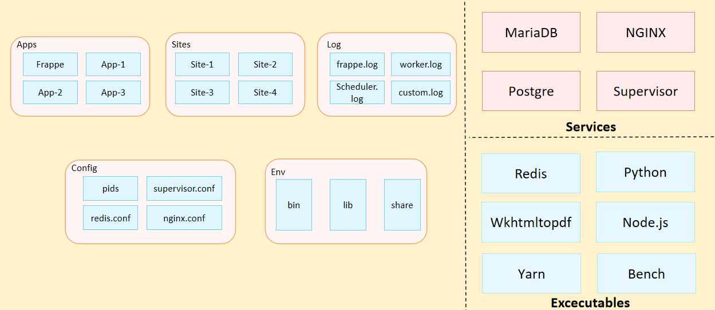
Fig: Architecture of Our Application

- Organization Structure:
Input required form WSC

- Design Overview:

6.1 Department
    - Overview
A Department is a specialized functional area or a division within an organization.

    - Description of Problem
Create a page containing all Information about department in the system including set Leave Block List, and also Leave and Expense Approvers for the same.

    - Dependency
Before creating a Department, it is advisable you create the following documents:
- Company

    - A Table of Contents
- Main Table:- TabDepartment
- Child Table:- TabDepartment Approver

    - Flow Chart
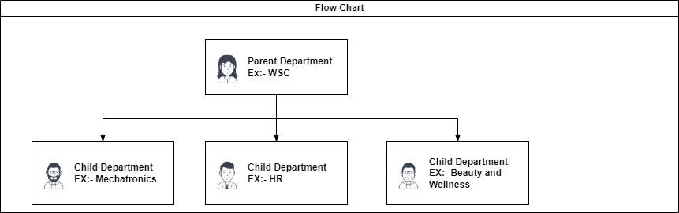

    - Use Case

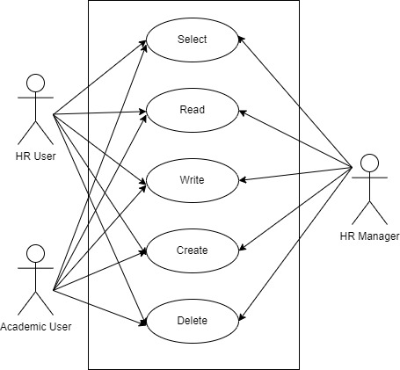

    - Form Elaboration
SL No | Label | Type | Mandatory
1 | Department | Data | 1
2 | Department Alias | Data | 1
3 | Parent Department | Link | 0
5 | Company | Link | 1
6 | Is Group | Check | 0
7 | Is Stream | Check | 0
8 | Disabled | Check | 0
10 | Payroll Cost Center | Link | 0
12 | Leave Block List | Link | 0
14 | Shift Request Approver | Table | 0
15 | Leave Approver | Table | 0
16 | Expense Approver | Table | 0
17 | lft | Int | 0
18 | rgt | Int | 0
19 | Old Parent | Data | 0

    - Screen Authorization
Sl No. | Role | Level | Select | Read | Write | Create | Delete | Submit
1 | HR User | 0 | 1 | 1 | 1 | 1 | 1 | 0
2 | Academics User | 0 | 1 | 1 | 1 | 1 | 1 | 0
3 | HR Manager | 0 | 1 | 1 | 1 | 1 | 1 | 0

    - Component And Module
Module Related:- Education, Finance, HR,Martial Management

    - Business Logic
- Go to the Department list, click on New.
- Enter Department name.
- Select Company name.
- Select Leave Block List (optional) applicable for this department.
- Save

    - Path of the screen
Home > Human Resources > Employee > Department

    - Pseudocode
This code defines a custom document type "Department" that is a nested set, meaning that each department can have one parent department and multiple child departments. It also provides some helper functions to manage the tree structure of departments.
The Department class inherits from NestedSet and sets the nsm_parent_field attribute to "parent_department". This defines the field that stores the parent department for each department in the tree.
The autoname method generates a unique name for each department by combining the department name with the company abbreviation. If the department is the root node of the tree, it uses the department name as the name.
The validate method sets the parent department to the root node if it is not set.
The before_rename method ensures that the name of the department is consistent with the company abbreviation when renamed.
The on_update method ensures that the nested set structure is updated after each update of a department.
The on_trash method ensures that any events associated with the department are deleted when it is deleted.
The on_doctype_update function adds an index on the left and right fields of the nested set structure.
The get_abbreviated_name function generates an abbreviated name for a department by combining the department name with the company abbreviation.
The get_children function retrieves all child departments of a given parent department or the root node of the tree.
The add_node function adds a new department to the tree.

  - Program Grades
    - Overview
The Program Grade document will hold all the mater data of the type of degree providing by the organization.

    - Description of Problem
Create a page containing all Information about a degree providing by the organization.

    - Dependency
No Dependency.
    - A Table of Contents
- Main Table- TabProgram Grades

    - Form Elaboration
SL No | Fields | Data Type | Mandatory
1 | Grade | Data | 1
2 | Description | Small Text | 0

    - Component And Module
Module Related:- Education.

    - Business Logic
The Program Grades document and enter the degree name and save.

  - Programs
    - Overview
The program document will hold a course of study leading to an academic degree. type of: course of study,Program Grade, Department,Programs Duration,No. of Semester and Semester.

    - Description of Problem
Create a page containing all Information about a Program and semester in the system including semester name.

    - Dependency
Dependent on Program Grade, Semester, Department

    - Table of Contents
- Main Table- TabPrograms
- Child Table- TabSemesters

    - Use Case
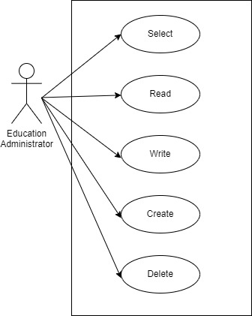

    - Form Elaboration
Sl No | Field Name | Type | Mandatory
1 | Program Grade | Link | 1
2 | Programs Name | Data | 1
3 | Department | Link | 0
4 | Description | Small Text | 0
5 | Programs Abbreviation | Data | 1
6 | Creation Date | Date | 0
7 | Programs Duration | Select | 1
8 | No. of Semesters | Int | 1
9 | Add Semesters | Button | 0
10 | Semesters | Table | 0
11 | Is Published | Check | 0
12 | Allow Self Enroll | Check | 0
13 | Is Featured | Check | 0
14 | Intro Video | Data | 0
15 | Hero Image | Attach Image | 0
16 | Description | Small Text | 0

    - Screen Authorization
User | Type of access
Education Administrator | Select/ Read/ Write/ Create/ Delete

    - Component And Module
Module Related:- Education

6.3.9 Business Logic

The Programs document will hold all the data of all the programs running in the organization including Department, Semester and program Grade,Programs Duration, Department etc.
- Go to the program list and click on New.
- Enter the Program Grade, Programs Name,Programs Duration and No. of Semesters.
- Save
- Then click on Add Semester Button to assign to the semester to the program.

6.3.10 Path of the screen
Home > Education >Programs.

6.3.11 Pseudocode
This is a Python script that defines a custom document type called "Programs". The document represents academic programs offered by an institution. The script contains several methods that define the behavior of the document, including validation of certain fields, creation of user permissions for instructors and directors, and creation of child documents called "semesters" and "courses".
The "validate" method is called whenever the document is saved or submitted. It calls two other methods, "validate_abbreviation" and "validate_no_semesters", to ensure that the abbreviation for the program is unique and that the number of semesters is greater than zero.
The "create_permissions" method is called when the document is saved and creates user permissions for instructors associated with the program's department. The method retrieves all instructor logs associated with the program's department and loops through each instructor to find their corresponding employee and user ID. It then uses the "add_user_permission" method from the "wsc.wsc.doctype.user_permission" module to create permissions for the program document for each user ID.
The "director_permission" method is similar to "create_permissions", but it creates user permissions for directors associated with the program's department instead of instructors.
The "on_change" method is called whenever the document is updated and removes semesters that are no longer needed. It retrieves all semesters associated with the program and checks if each semester is in the list of semesters for the program. If a semester is not in the list, it is deleted using the "delete_doc" method from the "frappe" module.
The "validate_no_semesters" method ensures that the "no_of_semesters" field is greater than zero. If it is not, it raises an error using the "throw" method from the "frappe" module.
The "validate_abbreviation" method ensures that the abbreviation for the program is unique. It retrieves all programs with the same abbreviation and raises an error if any are found.
The "create_semesters" method is called when the user clicks a button to create semesters for the program. It retrieves the number of semesters from the "no_of_semesters" field and creates a new semester for each number, using the "int_to_Roman" function to create a Roman numeral for the semester's name. If a semester already exists, the method sets the "is_existing" variable to true.
The "create_courses" method is called when the user saves a list of courses for a semester. It retrieves the courses from the "courses" parameter, which is a JSON-formatted string, and loops through each course to create a new child document called "Course". It then adds the course to the parent semester's "courses" field and saves the semester document.
Overall, this script defines the behavior of the "Programs" document type and includes methods for creating child documents, validating fields, and creating user permissions.

  - Semester
    - Overview
The Semester form will hold details of semester like which Department, Program it is associated with also this form contains all courses details that would be a part of curriculum in that semester.

    - Description of Problem
Create a page containing all Information about Semester along with courses which will be taught in it.

    - Table of Contents
- Main Table- TabProgram
- Child Table- TabProgram Course

    - Flow Chart
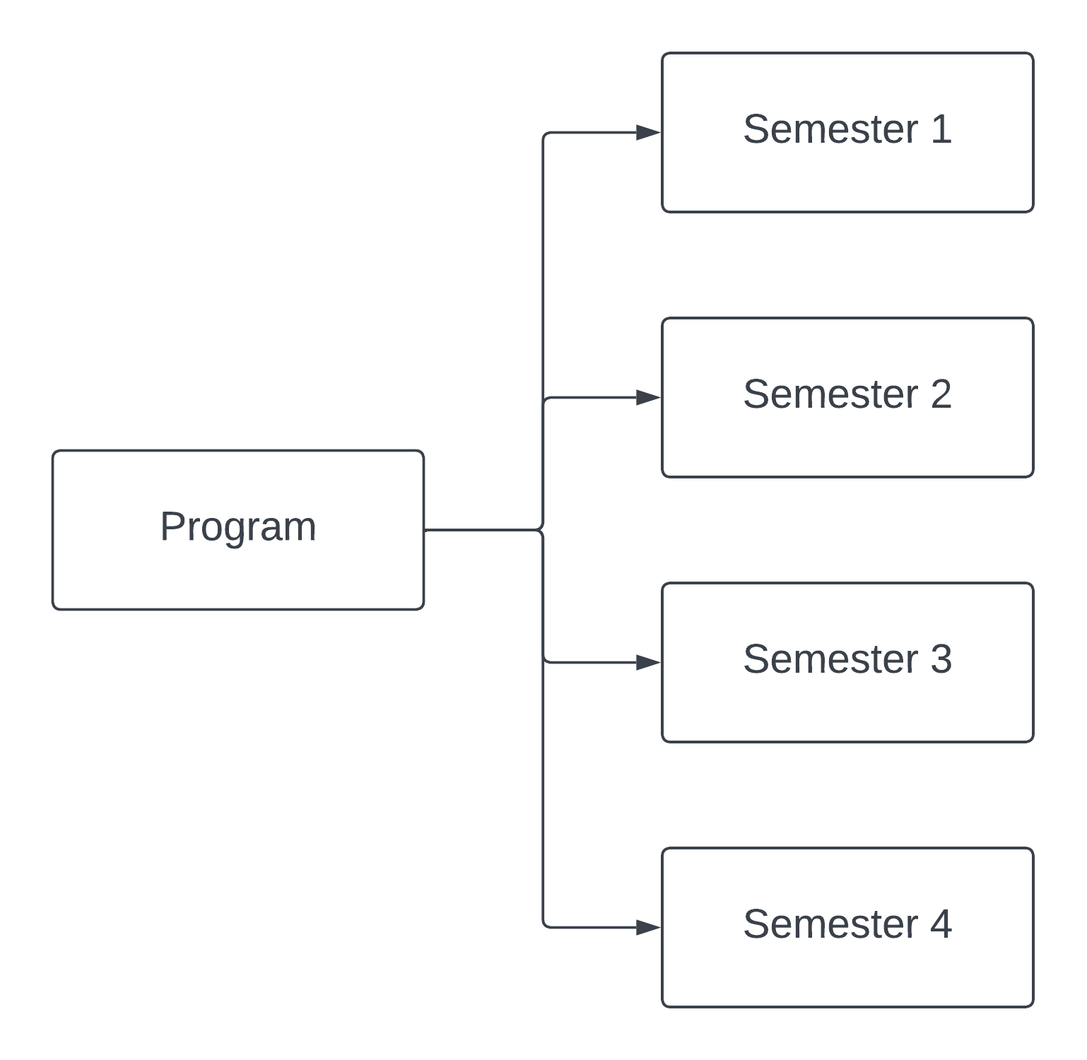

    - Flow Chart

    - Form Elaboration
Sl No. | Field name | Mandatory | Type
1 | Program Name | 1 | Data
2 | Department | 0 | Link
3 |  | 0 | Column Break
4 | Program Abbreviation | 0 | Data
5 | Courses | 0 | Section Break
6 | Courses | 0 | Table

    - Screen Authorization
User | Type of access
Education Administrator | Select/ Read/ Write/ Create/ Delete

    - Component And Module
Module: - Education Module

6.4.9 Business Logic
- Go to Semester List and click on New.
- Enter the Semester Name.
- Select the Programs name under which this semester would be made.
- Add the Semester Abbreviation.
- Add the Courses details like Course, Course name, Course code, Mandatory, Course Expiry date.
- Save.

6.4.10 Path of the screen
Home > Admission > Masters > Semester

6.4.11 Pseudocode
- Define a function called "after_insert" that takes two arguments "doc" and "method"
- Check if "doc" has a key called "programs" and if it has a value
- Get the "Programs" document using the value of "doc['programs']
- Check if "doc.program_name" is not in the list of "semesters" in the "programs" document
- Append a new semester to the "semesters" list in the "programs" document
- Update the number of semesters in the "programs" document
- Save the changes to the "programs" document
- Define a function called "validate_course_if_exists" that takes one argument "doc"
- Check if the length of "doc.courses" is not equal to zero
- Raise an exception with a message "Please Delete Courses from Semester"
  - Course
    - Overview
The Course document will hold all the data of Course Data, Credit distribution and the topics covered in the the course.

    - Description of Problem
Create a page containing all Information about a Course and Credit Distribution.

    - Table of Contents
- Main Table:- TabCourse
- Child Table:-
- TabCourse Credit
- TabCredit Distribution
- TabTopics
- TabAssessment Criteria

    - Flow Chart
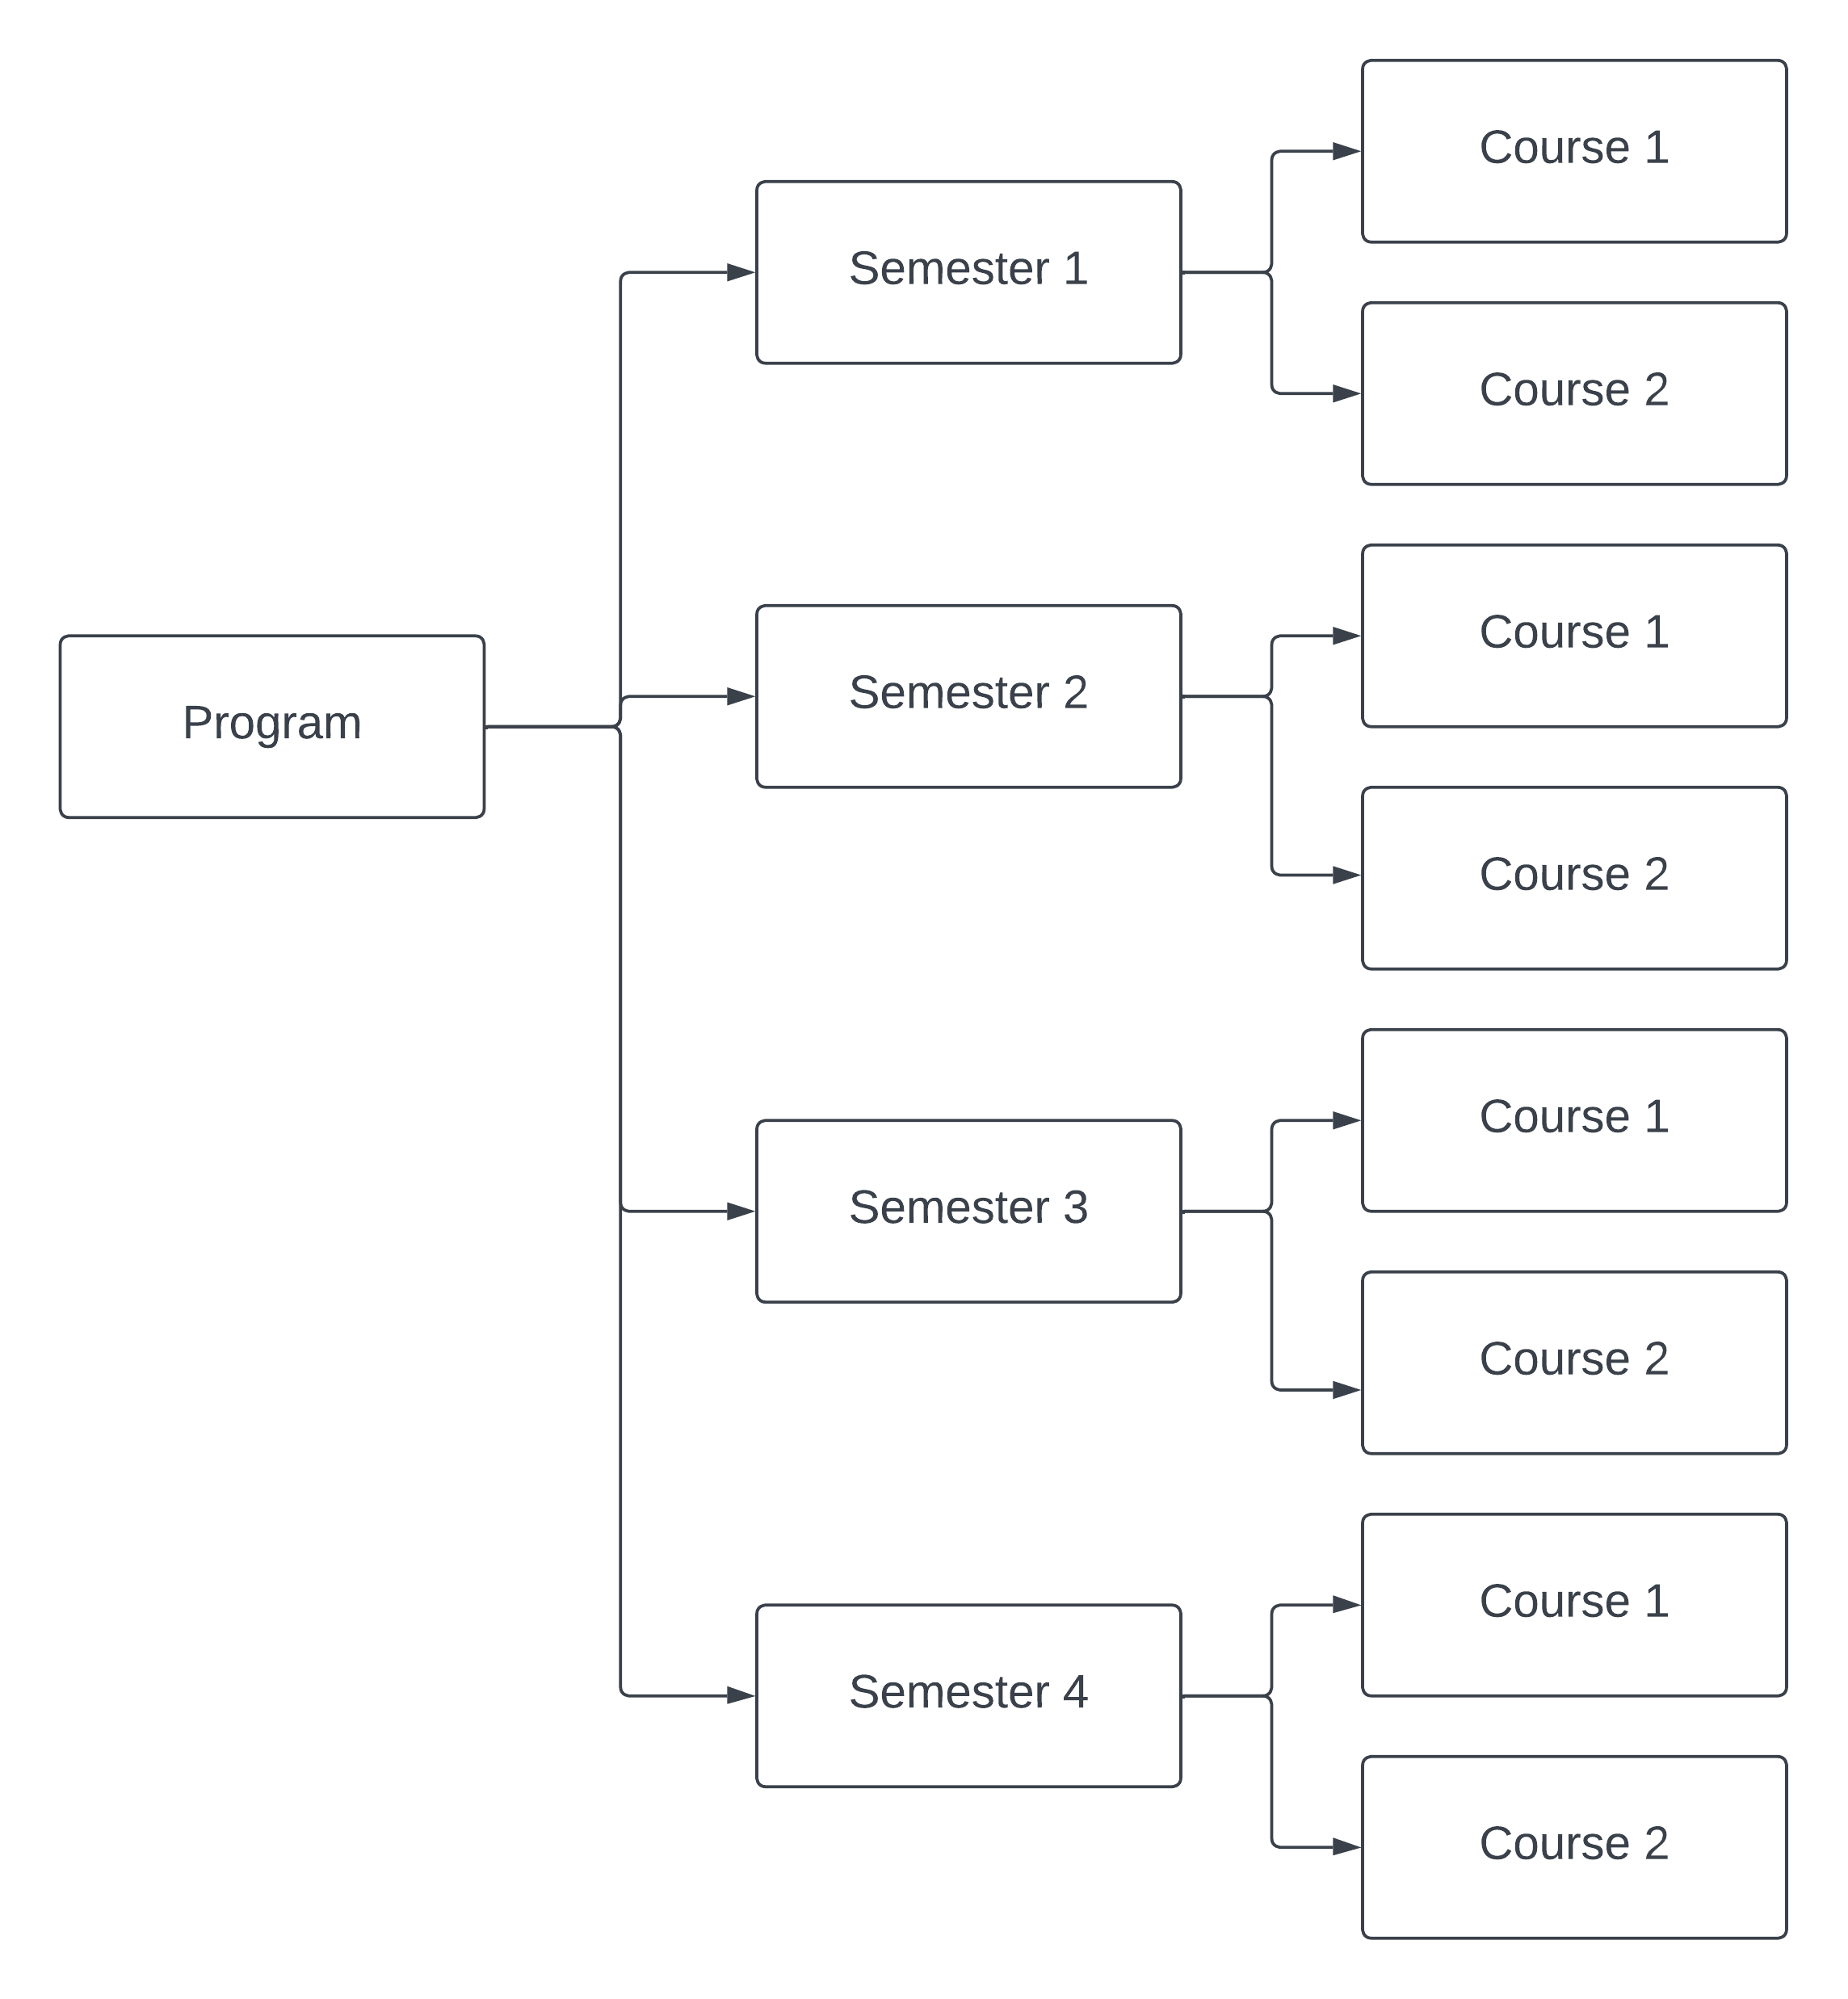
    - Use Case

    - Form Elaboration
Sl No | Field Name | Type | Mandatory
1 | Course Name | Data | 1
2 | Course Code | Data | 0
3 | idx | Data | 0
4 | Department | Link | 0
5 | Programs | Link | 0
6 | Semester | Link | 0
7 | Mode | Select | 0
8 | Course Expire Date | Date | 1
9 | Disable | Check | 0
10 | Course Credit | Table | 0
11 | Total Credit | Float | 0
12 | Passing Marks | Float | 0
13 | Total Marks | Float | 0
14 | Passing Credit | Float | 0
15 | Credit Distribution | Table | 0
16 | Topics | Table | 0
17 | Description | Small Text | 0
18 | Sect | Section Break | 0
19 | Hero Image | Attach Image | 0
20 | Assessment | Section Break | 0
21 | Default Grading Scale | Link | 0
22 | Assessment Criteria | Table | 0

    - Screen Authorization
User | Type of access
Education Administrator | Select/ Read/ Write/ Create/ Delete

    - Component And Module
Module: - Education Module

6.5.9 Business Logic
- Go to Course List and click on New.
- Enter the Course Name.
- Select the Department under which this course is being made.
- Add the Topics. You can also create the topics from here itself.
- Add the Description for the course.
- Save.
For every new Course a User can have a New Assessment setting where in they can define the criteria based on which the students will be assessed for the course.
- Default Grading Scale: A default Grading Scale can be set up for the course, wherein you can define what would be the achievement level of the student based on the scores they earn for a course.
- Assessment Criteria: You can define the Assessment Criteria for this course wherein based on the different parameters of assessment, the student's understanding of the subject would be assessed.

6.5.10 Path of the screen
Home > Education > Masters > Course

6.5.11 Pseudocode
This is a Python module for a custom document type called "Course" in the Frappe framework. It defines a class Course which inherits from Document. The Course document has fields such as assessment_criteria and topics. The validate method of the Course class calls the validate_assessment_criteria method to ensure that the total weightage of all assessment criteria is 100%. The get_topics method fetches the details of all topics associated with the course.
There are also two whitelisted functions: add_course_to_programs and get_programs_without_course. add_course_to_programs accepts a course name, a list of program names, and a boolean flag indicating whether the course is mandatory for the program. It then adds the course to the specified programs with the given mandatory flag. get_programs_without_course returns a list of program names that do not contain the specified course.
The module imports the json and frappe modules from the Frappe framework, and also imports the _ function from the frappe module for localization support.
validate: This function is called when a course document is saved. It calls several other validation functions to ensure that the data in the document is correct.
validate_semester: This function ensures that the semester selected for the course belongs to the program the course is associated with.
validate_max_credit: This function ensures that the passing marks and credits for each credit distribution item in the course do not exceed their respective total marks and credits, and it also calculates the total credit for the course.
validate_weightage_percentage: This function ensures that the total weightage for all credit distribution items in the course is exactly 100%.
get_semesters: This function returns a list of semesters associated with a program.
validate_credit: This function ensures that the total distribution of the course does not exceed the maximum credit allowed.
calculate_total: This function calculates the total passing marks, credits, and weightage percentage for the course.
add_course_to_programs: This function adds a course to all selected programs and saves the data.
check_for_semester: This function returns a list of semesters associated with a course.
get_semesters_name: This function returns a list of program names that do not have the specified course.

  - Room
    - Overview
The Room document will hold all the Class Room, Class Room No. and Seating Capacity.

    - Description of Problem
Create a page containing all Information about Class Room .

    - Table of Contents
- Main table: TabRoom

    - Form Elaboration
Sl No | Field Name | Type | Mandatory
1 | Room Name | Data | 1
2 | Room Number | Data | 0
3 | Seating Capacity | Data | 0

6.6.5 Component And Module
Module Related:- Education

6.6.6 Business Logic
The Room document will hold all the data of Class Rooms.
- Go to the Room list and click on New.
- Enter the Room Name, Room Number and Seating Capacity.
- Save.

6.6.7 Path of the screen
Home > Education > Master > Class Room

  - Academic Year
    - Overview
An academic year is a period which the Educational Institutes, Schools and Universities use to measure a quantity of study.
The Academic year form have the Start and End date for the Academic year.
Within an Academic Year, you can have multiple Academic Terms.

    - Description of Problem
An academic year is a period which the Educational Institutes, Schools and Universities use to measure a quantity of study.

    - Table of Contents
Main Table:- TabAcademic Year

    - Form Elaboration
SL no. | Field Name | Type | Mandatory
1 | Academic Year Name | Data | 1
2 | Year Start Date | Date | 0
3 | Year End Date | Date | 0

    - Screen Authorization
User | Type of access
Education Administrator | Read/ Write/ Modify

6.7.6 Component And Module
Module Related:- Education

6.7.7 Business Logic
The Academic year document will hold all the data of Academic Year .
1)Go to the Academic year list and click on New.
2) Enter the Academic Year Name, Year Start Date and Year End Date.
3) Save.

6.7.8 Path of the screen
Home > Admission > Master > Academic Year

6.7.9 Pseudocode
This is a Python script for the Academic Year class in the Frappe framework. The Academic Year class inherits from the Document class, which is a base class for all Frappe documents.
The validate method is called every time the document is saved, and it ensures that the year_start_date is earlier than the year_end_date. If the year_start_date is later than the year_end_date, it raises a frappe.throw error message to notify the user of the issue.

  - Academic Term
    - Overview
An Academic Term would become a part of the Academic Year, during which the Institute will assess its Students on the curriculum defined for that term. It could be a Quarter, Trimester or a Semester.
    - Description of Problem
An Academic Term would become a part of the Academic Year, during which the Institute will assess its Students on the curriculum defined for that term. It could be a Quarter, Trimester or a Semester.

    - Table of Contents
Main Table:- TabAcademic Term

    - Form Elaboration
SL no. | Fields Name | Type | Mandatory
1 | Academic Year Name | Data | 1
2 | Year Start Date | Date | 0
3 | Year End Date | Date | 0

    - Screen Authorization
User | Type of access
Education Administrator | Read/ Write/ Modify

6.8.6 Path of the screen
Home > Admission> Masters> Academic Term

6.8.7 Business Logic
Academic Term has been specified in the Education Settings then it will become the default Academic Term in all the forms and will be editable if required.
The following are the various forms where Academic Term is a relevant field:
- Student Log
- Student Group
- Student Applicant
- Student Admission
- Program Enrollment
- Assessment Plan
- Assessment Result
- Assessment Criteria
- Fees
- Fee Schedule
- Fee Structure
- Fee Category
- Course Schedule

6.8.8 Pseudocode
This code defines a Frappe Document for an Academic Term and performs some validations. The Document has an autoname function that sets the document name as the Academic Year concatenated with the Term Name. The validate function performs the following validations:
- Checks for duplicate entries with the same Academic Year and Term Name.
- Validates that the Term End Date is not earlier than the Term Start Date.
- Validates that the Term Start Date is not earlier than the Year Start Date of the Academic Year to which the term is linked.
- Validates that the Term End Date is not later than the Year End Date of the Academic Year to which the term is linked.
The validate_duplication function checks for any other Academic Term document that has the same academic year and term name as the current document, excluding itself. If a duplicate is found, it raises an error message.
Overall, this code ensures that the Academic Term documents have unique names and that the dates are within the range of the Academic Year to which the term is linked.

  - Instructor
    - Overview
An instructor is a teacher, tutor, or a professor that will be responsible for teaching a particular topic or course to the students.
This document can be used to maintain the Instructor Log in the form of a list of topics/courses covered by the Instructor. This log will have the entire history of the courses taught by the Instructor.

    - Description of Problem
An instructor is a teacher, tutor, or a professor that will be responsible for teaching a particular topic or course to the students.
    - Dependency
Before creating an instructor, it is advisable to first create the following:
- Employee
- Department
- Academic Year
- Academic Term
- Program
- Course
- Student Group

    - Table of Contents
Main Table:- tabInstructor

    - Use Case Diagram
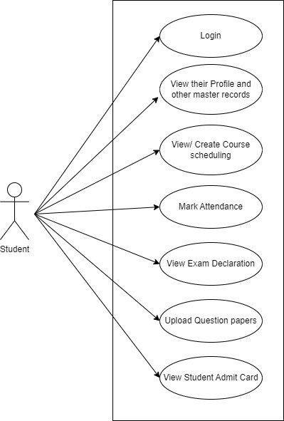

    - Form Elaboration
Sl No. | Field Name | Type | Mandatory
1 | Instructor Name | Data | 1
2 | Employee | Link | 0
3 | Gender | Link | 0
4 |  | Column Break | 0
5 | Status | Select | 0
6 | Naming Series | Select | 0
7 | Department | Link | 0
8 | Image | Attach Image | 0
9 | Instructor Log | Section Break | 0
10 | Instructor Log | Table | 0

    - Screen Authorization
User | Type of access
Education Administrator | Read/ Write/ Modify
Instructor | View

6.9.8 Component And Module
Module Related:- Education, HR

6.9.9 Business Logic
- Go to the Instructor list and click on New.
- Enter the Instructor name.
- Select if the Instructor is already added as an Employee in our system.
- Enter other details in Instructor log like for which academic term the Instructor is going to teach.
- Enter other activity details for teacher if any.
- Save.

6.9.10 Path of the screen
Home > Admission > Student and Instructor> Instructor

6.9.11 Pseudocode
- Define a function called "validate_instructor_log" that takes one argument "doc"
- Loop through the list of "instructor_log" in the "doc" argument
- Call the "validate_semester" function with the "d" argument
- Call the "validate_course" function with the "d" argument
- Define a function called "validate_academic_year" that takes one argument "doc"
- Check if the "academic_term" in the "doc" argument is not in the list of "name" in the "Academic Term" document
- Raise an exception with a message that shows the academic term and academic year that caused the exception
- Define a function called "validate_semester" that takes one argument "doc"
- Check if the "program" in the "doc" argument is not in the list of "semesters" in the "Semesters" document
- Raise an exception with a message that shows the semester and program that caused the exception
- Define a function called "validate_course" that takes one argument "doc"
- Check if the "course" in the "doc" argument is not in the list of courses returned by the "get_courses_by_semester" function with the "program" in the "doc" argument
- Raise an exception with a message that shows the course and program that caused the exception
- Create permission for instructor as he is assigned with any course to view course details like student enrolled in that course, time table, student groups, etc

  - Student
    - Overview
The Student document will hold all the data of any Student in your Academy like their Personal Information, Photo, Date of Birth, Address, etc.
    - Description of Problem
Create a page containing all Information about a student enrolled in the system including Personal details, Past educational information, Current educational details, etc.
    - Dependency
Dependent on Approval of Student Application form which is filled by student

    - A Table of Contents
- Main Table name :- TabStudent
- Child Table name :-
- TabPhysically Disabled
- TabAwards List
- TabCurrent Educational Details
- TabEducational Details
- TabSeminars And Guest Lecture
- TabStudent Sibling
- TabDocument List

    - Flow Chart

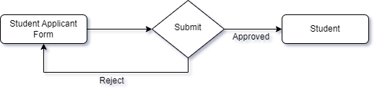

    - Use Case Diagram

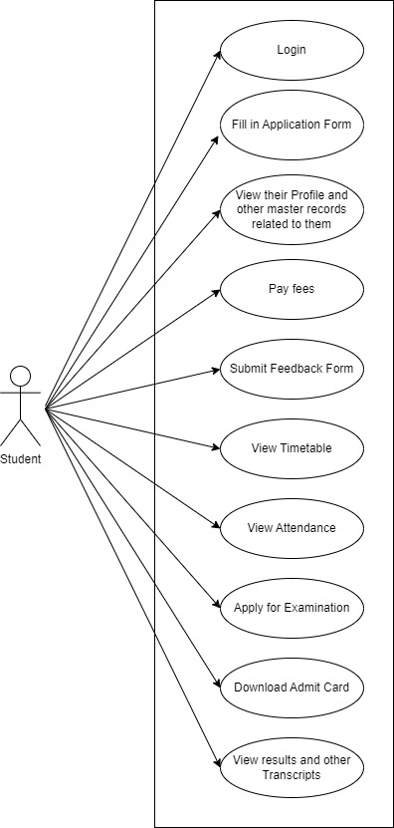

    - Form Elaboration

Fields | Type | Mandatory
First Name | Data | 1
Middle Name | Data | 0
Last Name | Data | 0
Program | Link | 1
Student Category | Link | 0
LMS Only | Check | 0
Paid | Check | 0
 | Column Break | 0
Naming Series | Select | 0
Application Status | Select | 0
Application Date | Date | 0
Academic Year | Link | 0
Academic Term | Link | 0
Student Admission | Link | 0
Image | Attach Image | 0
Personal Details | Section Break | 0
Date of Birth | Date | 0
Gender | Select | 0
Blood Group | Select | 0
 | Column Break | 0
Student Email Address | Data | 0
Student Mobile Number | Data | 0
Nationality | Data | 0
Home Address | Section Break | 0
Address Line 1 | Data | 0
Address Line 2 | Data | 0
Pin-code | Data | 0
 | Column Break | 0
City | Data | 0
State | Data | 0
Guardian Details | Section Break | 0
Guardians | Table | 0
Sibling Details | Section Break | 0
Siblings | Table | 0

    - Screen Authorization
User | Type of access
Education Administrator | Read/ Write/ Modify
Student | View

6.10.9 Component And Module
Module Related:- Education, Finance

6.10.10 Business Logic

The Student document will hold all the data of any Student in your Academy like their Personal Information, Photo, Date of Birth, Address, etc.
- Go to the student list and click on New.
- Enter the First Name, Middle Name and Last Name of the student.
- Enter other details like Student Email Address, User ID(If Applicable) and Joining Date.
- Save.

- Once a student is created in the system, you can also view the Accounting Ledger, which will show a report of all the payments made by the student.
- After program enrollment current education details will be visible

6.10.11 Path of the screen
Home > Education > Student and Instructor> Student

6.11 Student Admission

6.11.1 Overview
Student Admission is a document which can be configured to initiate an Admission Process for your institution.

6.11.2 Description of Problem
Create a page containing all Information about a student admission for a particular year containing details like Academic Year, Academic Term, Course, Eligibilty Paramter, etc.

6.11.3 Dependency
Dependent on following Doctypes:
- Academic Calendar Template
- Program
- Semester
- Academic Year
- Academic Term
- Eligibility Parameter List
- Required Documents
- Fee Structure

6.11.4 A Table of Contents
- Main Table name :- TabStudent Admission
- Child Table name :-
- TabReservations List
- TabStudent Admission Program
- TabRequired Documents
- TabEligibility Parameter List
- TabFee Structure Item

6.11.6 Use Case Diagram

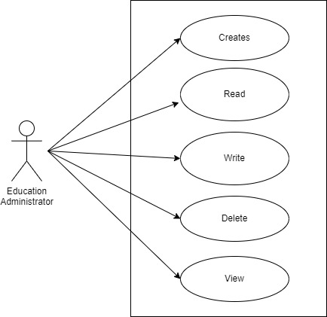

6.11.7 Form Elaboration

Fields | Type | Mandatory
Academic Calendar | Link | 0
Program Grade | Link | 0
Admission Program | Link | 1
Program Abbreviation | Data | 1
Semester | Link | 1
Academic Year | Link | 1
Academic Term | Link | 1
Counselling Details | Section Break | 0
Counselling Required | Check | 0
Counselling Start Date | Date | 0
Counselling End Date | Date | 0
Publish on website | Check | 0
Seats Reservation | Section Break | 0
Total Seats | Int | 0
Reservations Distribution | Table | 0
Enable Admission Application | Check | 0
Enrollment Details | Section Break | 0
Enrollment Start Date | Date | 1
Enrollment End Date | Date | 1
Eligibility and Details | Section Break | 0
Eligibility and Details | Table | 0
Required Documents list | Table | 0
Eligibility Parameter List | Table | 0
Admission Fees Details | Section Break | 0
Hostel Fees | Table | 0
Counselling Fees Applicable | Select | 0
Counselling Fee Structures | Table | 0
Admission Fees Applicable | Select | 0
Admission Fee Structure | Table | 0

6.11.8 Screen Authorization
User | Type of access
Education Administrator | Read/ Write/ Modify

6.11.9 Component And Module
Module Related:- Education

6.11.10 Business Logic

The Student Admission document will hold all the data of Student admission.
Go to the Student Admission list and click on Add Student Admission.
Enter the Title, Program Grade, Admission Program, Semester, Academic Year, Academic Term.
Enter other details like Counselling Details, Seats reservation, Enrollment Details, Eligibility Details, Admission Fees Details.
Save.

6.11.11 Path of the screen
Home > Admission > Application and Enrollment > Student Admission

6.11.12 Pseudocode
- Define a function to validate total seats for which admission would be published:
Initializes the total_seats variable to 0.
Checks if there are any reservations in the doc object.
If there are any reservations, it creates a list of all the reservation types in the document.
It then creates a list of reservation types that appear more than once in the document, indicating duplicates.
If there are any duplicates, it throws an error with a message stating that there are duplicate seat reservation types in the document.
It then loops through all the reservations in the document and adds up the number of allocated seats for each reservation, storing it in the total_seats variable.
For each reservation, it checks if the seat_balance is greater than the allocated_seat. If so, it throws an error stating that the seat balance should be less than or equal to the allocated seats for that reservation.
It then checks if the doc.total_seats is less than the total_seats and is greater than 0. If so, it throws an error stating that the total allocated seats should be less than or equal to the total seats in the document.
If the doc.total_seats is less than 0, it throws an error stating that the total seats should not be less than zero.
- Define a function to check students eligibility parameter.
It first checks whether there are any duplicate rows in the eligibility_parameter_list. It creates a list of dictionaries that contain the student_category and parameter values of each row, and then checks if there are any duplicates in the list. If there are duplicates, it throws an error using the frappe.throw function.
It then iterates over each row in the eligibility_parameter_list and checks if either the total_score or eligible_score attribute of the row is less than 0. If so, it throws an error using the frappe.throw function.
It then checks if the eligible_score attribute of the row is greater than the total_score attribute of the row. If so, it throws an error using the frappe.throw function.
- Define validate program to check if the program, academic year, academic calendar, program grade, semester, fee structure are valid.
- Define a function for validating document type to be uploaded.
It first checks whether the required_documents_list attribute has any rows. If it does, then it iterates over each row in the list and checks if the document_type attribute of the row is active. It does this by checking if the document_type is present in the name attribute of any row in the Documents Template table where the is_active attribute is 1. If the document_type is not active, it throws an error using the frappe.throw function.
It then checks for any duplicate rows in the required_documents_list. It creates a list of dictionaries that contain the student_category and document_type values of each row, and then checks if there are any duplicates in the list. If there are duplicates, it throws an error using the frappe.throw function.

6.12. Student Applicant

6.12.1 Overview
A Student Applicant record gets created when a student applies to your institute for admission.

6.12.2 Description of Problem
Create a form for Student to apply for admission into our web application.

6.12.3 Table of Contents
- Main Table name :- TabStudent Applicant
- Child Table name :-
- TabPhysically Disabled
- TabAwards List
- TabProgram Priority
- Rank Based Program Priority
- Counselling Based Program Priority
- Exam Center Preference
- Documents Required
- Education Qualification

6.12.4 Use Case Diagram
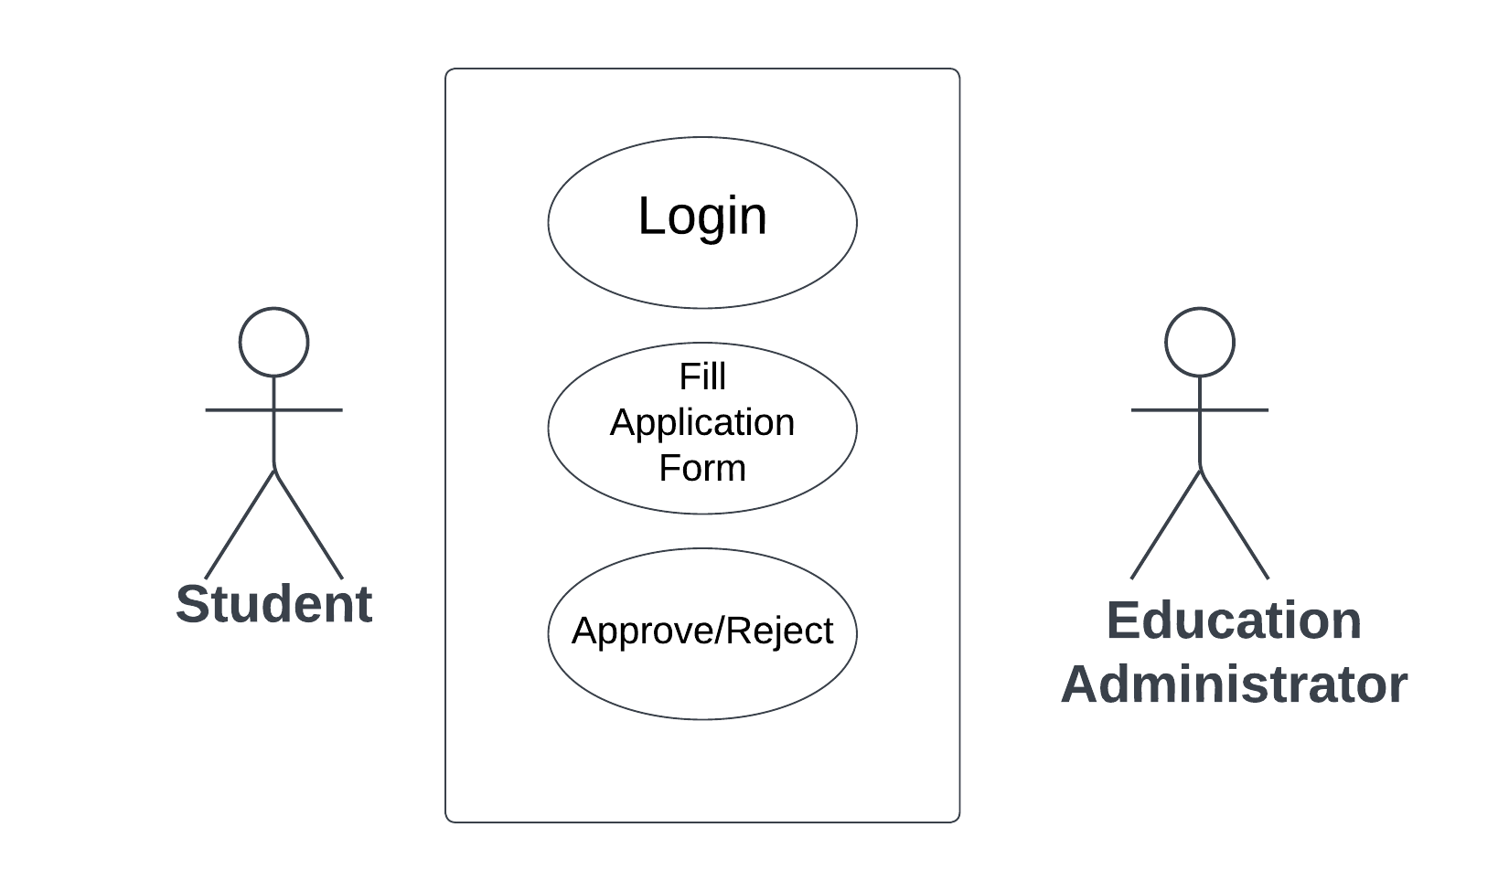

6.12.5 Form Elaboration
Sl No. | Field Name | Type | Mandatory
 | First Name | Data | 1
 | Middle Name | Data | 0
 | Last Name | Data | 0
 | Program | Link | 1
 | Programs |  | 0
 | Student Category | Link | 0
 | Physically Disabled | Check | 0
 | Physically Disabled | Table | 0
 | Hostel Required | Check | 0
 | Award Winner | Check | 0
 | Awards Winner List | Table | 0
 |  | Column Break | 0
 | Naming Series | Select | 0
 | Application Status | Select | 0
 | Application Date | Date | 0
 | Academic Year | Link | 0
 | Academic Term | Link | 0
 | Student Admission | Link | 0
 | Counselling Structure | Link | 0
 | Image | Attach Image | 0
 | Program Priority Details | Section Break | 0
 | Department | Link | 1
 | Program Grade | Link | 1
 | Program Priority | Table | 0
 | Student Rank List | Table | 0
 | Rank Based Program Priority | Table | 0
 | Counselling Based Program Priority | Table | 0
 | Hostel Details | Section Break | 0
 | Room Type | Link | 0
 |  | Column Break | 0
 | Personal Details | Section Break | 0
 | Date of Birth | Date | 0
 | Gender | Link | 0
 | Country Code | Data | 1
 | Religion | Link | 0
 | Blood Group | Select | 0
 |  | Column Break | 0
 | Student Email Address | Data | 0
 | Student Mobile Number | Data | 0
 | Nationality | Data | 0
 | Home Address | Section Break | 0
 | States | Link | 1
 | Districts | Link | 0
 | Blocks | Link | 0
 | Post Office | Data | 0
 | Address Line 1 | Data | 0
 | Address Line 2 | Data | 0
 | Pincode | Data | 0
 |  | Column Break | 0
 | Block | Data | 0
 | At Post | Data | 0
 | District | Data | 0
 | City | Data | 0
 | Address Line 1 | Data | 0
 | Address Line 2 | Data | 0
 | Pincode | Data | 0
 | Education Details | Section Break | 0
 | Education Qualifications Details | Table | 1
 | Documents Required | Section Break | 0
 | Document List | Table | 0
 | Fees | Section Break | 0
 | Total Counselling Fee | Currency | 0
 | Admission Fees | Table | 0
 | State | Data | 0
 | Guardian Details | Section Break | 0
 | Guardians | Table | 0
 | Guardian Details | Section Break | 0
 | Father's Name | Data | 0
 | Fathers Contact Number | Data | 0
 | Father's Qualification | Data | 0
 | Father's Occupation | Select | 0
 | Father's Annual Income | Currency | 0
 | Fathers Occupation | Data | 0
 | Annual Income | Select | 0
 |  | Column Break | 0
 | Mother's Name | Data | 0
 | Mothers Contact Number | Data | 0
 | Mother's Qualification | Select | 0
 | Mother's Occupation | Data | 0
 | Mothers Occupation | Select | 0
 | Mother's Annual Income | Currency | 0
 |  | Column Break | 0
 | Local Guardian's Name | Data | 0
 | Local Guardian Contact No. | Data | 0
 | Relation with Student | Data | 0
 | Local Guardian Occupation | Select | 0
 | Local Guardian Address | Data | 0
 | Sibling Details | Section Break | 0
 | Siblings | Table | 0
 |  | Section Break | 0
 | Title | Data | 0
 |  | Section Break | 0
 | Bank Details | Section Break | 0
 | Account Holder Name | Data | 0
 | Bank Name | Select | 0
 | Bank Name | Data | 0
 |  | Column Break | 0
 | Account Type | Link | 0
 | IFSC Code | Data | 0
 | Bank Account No | Data | 0
 | Guardian Details | Table | 0
 | Print Format Selector | Data | 0
 | Date | Date | 0

6.12.6 Screen Authorization
User | Type of access
Education Administrator | Read/ Write/ Modify
Student | Write

6.12.7 Component And Module
Module Related:- Education

6.12.8 Business Logic

The Student Application document will hold all the data of any Student in your Academy like their Personal Information, Photo, Date of Birth, Address, etc.
- Go to the Student Applicant list and click on Add Student Applicant.
- Enter all necessary details including students Personal, academic, Parents, other details.
- Save.
After student fills this form and saves it goes to the education administrator who has the access to either accept this application or reject it.

6.12.9 Path of the screen
Home > Admission > Application and Enrollment > Student Applicant

6.12.10 Pseudocode
- Define function which will create Student once the Student Application form is approved.
- The code first checks if the document status is 1, which is an approved status, and then it checks if a student record already exists for the student applicant.
- If no student record exists and the student applicant is approved, then the code uses the get_mapped_doc function to map the fields from the student applicant record to the student record and then saves the student record.
- The code should also check if the required fields such as account_name, bank, account_type, branch_code, and bank_account_no are filled in the application. If they are filled, the code should create a new document (acc_doc) of type 'Bank Account' and assigns values to the fields such as account_name, bank, account_type, branch_code, and bank_account_no. It then assigns the party_type as 'Student' and assigns the party as the name of the Student. Finally, it saves the document and displays a message that the Bank Account has been created.
- Define validate method from which methods like education_details_validation, document_list_checkbox, mobile_number_validation, validate_pin_code, validate_seat_reservation_type, get_admission_fees, email_validation.
- In education_details_validation, check if the student has filled in valid Educational Details in the appropriate field.
- In document_list_checkbox, check if the student has attached the required documents or not.
- In mobile_number_validation, check if all the mobile numbers entered in the form are valid 10 digit numbers only and no alphabets, etc.
- In validate_pin_code, check if the pin code entered is a 6 digit number.
- In validate_seat_reservation_type, first creates a list of seat reservation types (seat_reservation_type_list) from the Reservations List table using the student_admission field. then checks if the doc (presumably a parent document) contains the fields physically_disabled or award_winner. If the doc does contain one of those fields, it creates a list of seat reservation types that match that criteria. If the resulting list is empty, it throws an error.
- In get_admission_fees, fetch the admission fees based on the program that the student selects during form fill-up.
- In email_validation, check if all the emails are valid or not.
- Define get_document_list_by_category, This code is used to get a list of documents based on a student's category. It takes in a parameter, doc, which is a document. The code then creates a filter with the student's category, which will be used to query the database. It also checks to see if the student has a counselling structure, and if not, it adds a filter for the student's admission and sets the group_by variable to document_name. Finally, the code queries the database for the documents template list and their mandatory and availability status, returns the list, and if the list is empty it returns an empty list.
- Define enroll_student, This method is used to enroll a student in a program. It starts by importing the necessary functions from the modules student_exchange_applicant and semesters. Then it gets the document of the student applicant with the given source name using the frappe.get_doc() function. The method then iterates through the list of student records associated with the student applicant and creates a new Program Enrollment document. It sets the necessary fields such as student, student_category, student_name, roll_no, programs, program, academic_year, academic_term, reference_doctype, reference_name, program_grade, gender, physically_disabled, award_winner and boarding_student. The method then appends the disable_type and awards_list fields with the data from the student applicant document. It then checks if the program is set and if it is, it appends the courses field with the courses from the program. The method then checks if the student admission document is set and if it is, it appends the fee_structure_item and academic_events_table fields with the data from the student admission document.
- Define show_fees_button, This method is used to check whether a student application should show a 'Show Fees' button or not. It checks the student admission document and if the counselling fees is set to 'YES', then it checks the fees documents for the student to check if any fees have been paid. If any fees have been paid then the 'Show Fees' button should not be displayed. If no fees have been paid or the counselling fees is set to 'NO' then the 'Show Fees' button should be displayed.
- Define validate_attachment, This method is used to validate document attachments. Specifically, it checks whether all mandatory documents have been attached. The function takes a document object as an argument. It then iterates through the list of documents associated with the document object and checks for each one if it is marked as mandatory and if it has been attached. If the document is marked as mandatory but has not been attached, a frappe.throw() error is raised.
- Define validate_student_admission,
- This method is used to validate the student admission in a program priority. It checks if the student admission already exists in the counselling structure. It first retrieves the student admission and name from the program priority and student applicant tables. It then checks if the student admission is present in the retrieved data. If the student admission is present, it throws an error with the student admission and name of the counselling structure.
- Define applicant_rank: - This method will be used to fetch and fill details regarding rank obtained by the student in the entrance exam . Also this method will only run when rank cards are being generated. Also when ranks are generated the child tables named Rank based counselling will be visible and applicant will need to fill their program priority as per ranks obtained.
- During Counselling the documents need to be verified by counselling officer. Applicants will present their physical documents and that will be matched will the documents uploaded and a checkbox called Approved in the document required child table need ticked as per presented documents
- During Counselling ,a checkbox needs to be checked and a table named Counselling Based Program Priority will appear and applicant will need to fill their program priority based on availability of seats.
- As per availability , the student will be allotted a seat in their preferred course and the student applicant form will be approved by the counselling officer. After approval the applicant’s status of admission will be marked as provision admission
- After the applicant clears fees for the semester that applicant’s admission status will be changed to admitted

6.13. Program Enrollment

6.13.1 Overview
A Program Enrollment record gets created when a student gets enrolled in their choice of program.

6.13.2 Description of Problem
Create a form to enroll student in the choice of their program.

6.13.3 Table of Contents
- Main Table name :- TabProgram Enrollment
- Child Table name :-
- TabAwards List
- TabPhysically Disabled
- TabProgram Enrollment Course
- TabProgram Fee
- TabFee Structure Item
- TabAcademic Events Table

6.13.4 Use Case Diagram

6.13.5 Form Elaboration
Sl No. | Field name | Field type | Mandatory
1 | Student | Link | 1
2 | Student Name | Read Only | 0
3 | Roll No | Data | 0
4 | Gender | Link | 0
5 | Student Category | Link | 0
6 | Student Batch | Link | 0
7 | School House | Link | 0
8 | Award Winner | Check | 0
9 | Awards List | Table | 0
10 | Physically Disabled | Check | 0
11 | Disable Type | Table | 0
12 | Is Provisional Admission | Select | 1
13 | Seat Holding till | Date | 0
14 |  | Column Break | 0
15 | Admission Status | Select | 0
16 | Exam Status | Select | 0
17 | Program Grade | Link | 1
18 | Programs | Link | 1
19 | Permanent Registration Number | Data | 0
20 | Program | Link | 1
21 | Academic Batch | Data | 0
22 | Academic Year | Link | 1
23 | Academic Term | Link | 0
24 | Year End Date | Date | 0
25 | Enrollment Date | Date | 1
26 | Seat Reservation Type | Link | 0
27 | Available seats | Int | 0
28 | Boarding Student | Check | 0
29 | Enrolled courses | Section Break | 0
31 | Courses | Table | 0
31 | Transportation | Section Break | 0
32 | Mode of Transportation | Select | 0
33 |  | Column Break | 0
34 | Vehicle/Bus Number | Data | 0
35 | Fees | Section Break | 0
36 | Fees | Table | 0
37 | Due Date | Date
38 | Fee Structure Item | Table | 0
39 | Academic Calendar | Section Break | 0
40 | Academic Events Table | Table | 0
41 | References | Section Break | 0
42 | Reference Doctype | Select | 0
43 |  | Column Break | 0
44 | Reference Name | Dynamic Link | 0
45 | Voucher No. | Data | 0
46 | Company | Data | 0

6.13.6 Screen Authorization
User | Type of access
Education Administrator | Read/ Write/ Modify

6.13.7 Component And Module
Module Related:- Education

6.13.8 Business Logic

- Go to Program Enrollment list and click on Add Program Enrollment.
- Enter all necessary details including students details, Program details like Program name, semester in which they would be enrolled and other details.
- After selecting program all courses associated with it will be linked in the table below.
- Save and submit to create student Program Enrollment.

6.13.9 Path of the screen
Home > Admission > Application and Enrollment > Program Enrollment

6.13.10 Pseudocode
1. Define set_duration, This method is setting the duration of an academic event, using the date_diff() function to calculate the difference between the end date and the start date of the event. It does this by looping through the academic events table of the document and setting the duration of each event to the result of the date_diff() function.
2. Define on_change, This method will be executed when a change is made to the document. It retrieves the student document based on the student id and sets the roll number and permanent registration number from the program enrollment document. It then iterates through the courses in the program enrollment document and sets the course name based on the course id. The validate_enrollment_admission_status() function is called to validate the admission status. Finally, if the document status is set to 1 and the admission status is set to "Provisional Admission", the program_enrollment_provisional_admission() function is called. Otherwise, the program_enrollment_admitted() function is called.
3. Define update_student, This method-updates the record of a student in Frappe. First, it gets the student record using the `frappe.get_doc` function. Then, it updates the student's roll number with the value from the document. Next, it sets the student's current education to an empty array. Finally, it appends the current education details to the array and saves the student record.
4. The method begins by creating fee records, creating the student, and updating the enrollment and admission status. It then gets the fee structure associated with the student and checks to see if they are a year back student (if they are in the same program and academic year as they were last year). If they are not a year back, it will create the fees associated with the fee structure. If they are a year back, it will output a message saying that the student is a year back and no fees will be charged.
5. Define fee_structure_validation, This method will be checking whether a fee structure exists for a certain program, fee type, academic year, and academic term. It first uses the frappe.db.get_list() function to get a list of all fee structures that match these criteria. The criteria is specified in the dictionary that is the second argument to the function. If there is an existing fee structure, the code returns the fee structure ID. Otherwise, it displays a message that the fees are not found.
6. Define create_fees, This method creates a fees document and submits it. It takes the parameters 'doc', 'fee_structure_id', and 'on_submit' as arguments. The code gets data from the Program Enrollment document such as the student, program, student batch name, student name, roll no, student category, academic year, and academic term. It then creates a new fees document with the given information and appends the fee components from the Fee Component table. It then checks to make sure a due date has been entered and sets the voucher no of the Program Enrollment document to the name of the created fees document. Finally it submits the fees document.
7. Define update_reserved_seats, This method is used to update the number of reserved seats for a particular program. It checks if the reference document is a "Student Applicant" or a "Branch Sliding Application". If it is a Student Applicant, it checks if the reservation type exists in the admission and if the checkbox values are correct. If they are correct, it updates the seat balance. If it is a Branch Sliding Application, it updates the available seats in the Branch Sliding Declaration and validates and submits the declaration.
8. Define create_student, This method is used to create a student record in Frappe. It first gets the student document using the student id. It then sets the current education details, such as programs, semesters, academic year, and academic term, in the student document. It then checks if the student has an email id and if a user document with the same email id exists. If the user document exists, it gets the user document and sets the first and last name, module profile, and enabled status to 1. It then sets the student user to the student email id and saves the user document. Finally, it sets the permission to student and adds the enrollment details to the student document and saves the document.
9. Define make_fee_records, This method is used to create fee records for a student applicant. It first checks if the reference document is a Student Applicant. It then gets the fee components of the fee structure provided. It then creates a new document of type Fees, and updates it with the student's name, academic year, term, program, and the fee structure. It then gets the due date of the Fee Structure Item and updates the Fees document with the due date. Finally, it saves and submits the new Fees document. The fee list is then created and the Fee Records are printed out.

6.14. Course Enrollment

6.14.1 Overview
A Course Enrollment record gets created when Program Enrollment of a student happens for any program.

6.14.2 Description of Problem
Create a form to enroll student in the choice of their Courses.

6.14.3 Table of Contents
- Main Table name :- TabCourse Enrollment
- Child Table name :-
- TabAwards List
- TabPhysically Disabled
- TabProgram Enrollment Course
- TabProgram Fee
- TabFee Structure Item
- TabAcademic Events Table

6.14.4 Use Case Diagram

6.14.5 Form Elaboration
Sl No. | Field name | Field type | Mandatory
1 | Program Enrollment | Link | 1
2 | Student | Link | 0
3 | Student Name | Data | 0
4 | Roll No | Data | 0
5 | Registration Number | Data | 0
6 |  | Column Break | 0
7 | Status | Select | 0
8 | Programs | Link | 0
9 | Semester | Link | 0
10 | Course | Link | 0
11 | Course Name | Data | 0
12 | Course Code | Data | 1
13 | Academic Term | Link | 0
14 | Academic Year | Link | 0
15 | Enrollment Date | Date | 0
16 | Credit Allocation | Section Break | 0
17 | Total Credits | Float | 1
18 | Passing Credits | Float | 1
19 | Credit distribution | Table | 0
20 | Grading Scale | Link | 1
21 | Total Course Marks | Float | 0
22 | Course Passing Marks | Float | 1

6.14.6 Screen Authorization
User | Type of access
Education Administrator | Read/ Write/ Modify

6.14.7 Component And Module
Module Related:- Education

6.14.8 Business Logic

- Go to the Course Enrollment list and click on Add Course Enrollment.
- Select Student from list in Program Enrollment field.
- Enter Course, Academic Term, Academic Year, Enrollment date.
- Save.

6.14.9 Path of the screen
Home > Admission > Application and Enrollment > Program Enrollment

6.15. Fee Category

6.15.1 Overview
Fee Category would form all the components for calculation of Fees or creation of Fee Structure.

6.15.2 Description of Problem
Create a form to enter Fee Category.

6.15.3 Table of Contents
- Main Table name :- TabFee Category

6.15.4 Use Case Diagram

6.15.5 Form Elaboration
Sl No. | Field name | Field type | Mandatory
1 | Category Name | Data | 1
2 | Description | Long Data | 0

6.15.6 Screen Authorization
User | Type of access
Education Administrator | Read/ Write/ Modify/ Delete

6.15.7 Component And Module
Module Related:- Education, Accounts

6.15.8 Business Logic

- Go to Fee Category and click on add Fee Category.
- Add Fee category name, description.
- Save

6.15.9 Path of the screen
Home > Admission > Fees > Fee Structure

6.16. Fee Structure

6.16.1 Overview
A Fee Structure is a template that can be used while making Fees records or generating them via the Fee Schedule.

6.16.2 Description of Problem
Create a form to enter Fee Structure.

6.16.3 Table of Contents
1) Main Table name :- TabFee Structure
2) Child Table name :-
- TabCourse Wise Fees
- TabFee Component

6.16.4 Use Case Diagram

6.16.5 Form Elaboration
Sl No. | Field name | Field type | Mandatory
1 | Is Hostel Fees | Select | 0
2 | Program Grade | Check | 0
3 | Programs | Link | 0
4 | Program | Link | 0
5 | Student Category | Link | 0
6 | Fee Type | Link | 1
7 | Exam Type | Link | 0
8 |  | Column Break | 0
9 | Academic Year | Link | 1
10 | Academic Term | Link | 0
11 |  | Section Break | 0
12 | Course Wise Fees | Table | 0
13 | Components | Table | 1
14 |  | Section Break | 0
15 |  | Column Break | 0
16 | Total Amount | Currency | 0
17 | Accounts | Section Break | 0
18 | Receivable Account | Link | 1
19 | Income Account | Link | 0
20 |  | Column Break | 0
21 | Company | Link | 0
22 | Accounting Dimensions | Section Break | 0
23 | Cost Center | Link | 0

6.16.6 Screen Authorization
User | Type of access
Education Administrator | Read/ Write/ Modify/ Delete

6.16.7 Component And Module
Module Related:- Education, Accounts

6.16.8 Business Logic

- Go to Fee Structure and click on add Fee Structure.
- Add Program grade, Program, Semester, Student Category, Fee type, Academic year, Academic Term.
- Save

6.16.9 Path of the screen
Home > Admission > Fees > Fee Structure

6.17. Fees

6.17.1 Overview
In this form, Fee Records of the students can be maintained.

6.17.2 Description of Problem
Create a form to enter Fees.

6.17.3 Table of Contents
1) Main Table name :- TabFees
2) Child Table name :- TabFee Component

6.17.4 Use Case Diagram

6.17.5 Form Elaboration
Sl No. | Field name | Field type | Mandatory
1 | Student | Link | 0
2 | Student Name | Data | 1
3 | Roll No | Data | 0
4 | Registration Number | Data | 0
5 | Fee Schedule | Link | 0
6 | Include Payment | Check | 0
7 | Send Payment Request | Check | 0
8 | valid From | Date | 0
9 | Valid To | Date | 0
10 | Is Return | Check | 0
11 | Return Issued | Check | 0
12 |  | Column Break | 0
13 | Institution | Link | 1
14 | Date | Date | 1
15 | Posting Time | Time | 0
16 | Edit Posting Date and Time | Check | 0
17 | Due Date | Date | 1
18 | Student Details | Section Break | 0
19 | Program Enrollment | Link | 0
20 | Programs | Link | 1
21 | Semester | Link | 1
22 | Student Batch | Link | 0
23 | Student Email | Date | 0
24 |  | Column Break | 0
25 | Student Category | Link | 0
26 | Academic Term | Link | 0
27 | Academic Year | Link | 0
28 |  | Section Break | 0
29 | Currency | Link | 0
31 | Fee Structure | Link | 0
31 | Hostel Fee Structure | Link | 0
32 | Components | Table | 1
33 |  | Section Break | 0
34 | Grand Total | Currency | 0
35 | In Words | Data | 0
36 | Outstanding Amount | Currency | 0
37 | Fees Waiver | Section Break | 0
38 | Waiver Type | Select | 0
39 | Percentage | Date | 0
40 | Amount | Currency | 0
41 | Waiver Amount | Currency | 0
42 | Printing Settings | Section Break | 0
43 | Letter Head | Link | 0
44 |  | Column Break | 0
45 | Exam Application | Link | 0
46 | Print Heading | Link | 0
47 | Accounting | Section Break | 0
48 | Receivable Account | Link | 1
49 |  | Column Break | 0
50 | Return Against | Link | 0
51 | Income Account | Link | 0
52 | Accounting Dimensions | Section Break | 0
53 | Cost Center | Link | 0
54 |  | Column Break | 0
55 | Hostel Admission | Link | 0
56 | References | Section Break | 0
57 | Reference Doctype | Link | 0
58 |  | Column Break | 0
59 | Reference Docname | Dynamic Link | 0
60 |  | Column Break | 0
61 | Has Program Enrollment | Check | 0
62 | Allotting Employee | Section Break | 0
63 | Employee | Data | 0
64 |  | Column Break | 0
65 | Employee Name | Data | 0

6.17.6 Screen Authorization
User | Type of access
Education Administrator | Read/ Write/ Modify/ Delete
Student | Write(Pay fees)

6.17.7 Component And Module
Module Related:- Education, Accounts

6.17.8 Business Logic

- Go to Fees and click on add Fees.
- Add Student from list of students appearing in the field, Valid from, Valid to, Due date, Fee structure.
- Save.

6.17.9 Path of the screen
Home > Admission > Fees > Fees

6.18. Fee Schedule

6.18.1 Overview
Fee Schedule would help in defining a time-line for the Fee payment of the students, based on the Student Group.

6.18.2 Description of Problem
Create a form to Schedule fees for all students based on Student Group.

6.18.3 Table of Contents
1) Main Table name :- TabFee Schedule
2) Child Table name :-
- TabFee Schedule Student Group
- TabFee Component

6.18.4 Use Case Diagram

6.18.5 Form Elaboration
Sl No. | Field name | Field type | Mandatory
1 | Fee Structure | Link | 1
2 | Posting Date | Date | 1
3 | Due Date | Date | 1
4 | Fee Creation Status | Select | 0
5 | Send Payment Request Email | Check | 0
6 |  | Column break | 0
7 | Student Category | Link | 0
8 | Programs | Link | 0
9 | Program | Link | 0
10 | Academic Year | Link | 1
11 | Academic Term | Link | 0
12 |  | Section break | 0
13 | Currency | Link | 0
14 | Student Group | Table | 1
15 | Fee Breakup for each student | Section break | 0
16 | Fee Components | Table | 0
17 |  | Section break | 0
18 |  | Column break | 0
19 | Total Amount per Student | Currency | 0
20 | Grand Total | Currency | 0
21 | In Words | Date | 0
22 | Printing Settings | Section break | 0
23 | Letter Head | Link | 0
24 |  | Column break | 0
25 | Print Heading | Link | 0
26 | Accounting | Section break | 0
27 | Receivable Account | Link | 0
28 | Income Account | Link | 0
29 |  | Column break | 0
31 | Institution | Link | 0
31 | Accounting Dimensions | Section break | 0
32 | Cost Center | Link | 0

6.18.6 Screen Authorization
User | Type of access
Education Administrator | Read/ Write/ Modify/ Delete

6.18.7 Component And Module
Module Related:- Education, Accounts

6.18.8 Business Logic
- Go to the Fee Schedule list and click on New.
- Select and add the Fee Structure. The moment you add the Fee Structure, the Fee Break Up for Each Student will be auto-populated.
- Select and add the Academic Year and the Academic Term.
- Add the Due Date for the fees.
- Select and add the Student Group.
- Save and Submit.

6.18.9 Path of the screen
Home > Admission > Fees > Fee Schedule

6.19. Document Template

6.19.1 Overview
Document Template is a form which stores list of documents to be uploaded by the student at the time of admission.

6.19.2 Description of Problem
Create a form to define different documents to be up;oaded by students during admission.

6.19.3 Table of Contents
1) Main Table name :- TabFee Schedule
2) Child Table name :- TabDocuments Template List

6.19.4 Use Case Diagram

6.19.5 Form Elaboration
Sl No. | Field name | Field type | Mandatory
1 | Template Name | Data | 0
2 | Academic Year | Link | 1
3 | Is Active | Check | 0
4 | Description | Small Text | 0
5 | Student Category | Link | 1
6 |  | Section Break | 0
7 | Documents Required | Table | 0

6.18.6 Screen Authorization
User | Type of access
Education Administrator | Read/ Write/ Modify/ Delete

6.19.7 Component And Module
Module Related:- Education

6.19.8 Business Logic
- Go to Documents Template List and click on Add Documents Template.
- Enter Template Name, Academic Year, Description, Student Category, Document name for required documents and if it is mandatory or not.
- Save.

6.19.9 Path of the screen
Home > Admission > Admission master > Documents Template

6.20. Academic Calendar Template

6.20.1 Overview
Academic Calendar template is a form where where we enter all events for a program in a Academic year.

6.20.2 Description of Problem
Create a form to enter all events for a program.

6.20.3 Table of Contents
1) Main Table name :- TabAcademic Calendar Template
2) Child Table name :- TabAcademic Events Table

6.20.4 Use Case Diagram

6.20.5 Form Elaboration
Sl No. | Field name | Field type | Mandatory
1 | Template Name | Data | 0
2 | Academic Year | Link | 1
3 | Programs | Link | 1
4 | Semester | Link | 1
5 | Academic Events table | Table | 0

6.20.6 Screen Authorization
User | Type of access
Education Administrator | Read/ Write/ Modify/ Delete

6.20.7 Component And Module
Module Related:- Education

6.20.8 Business Logic
- Go to Academic Calendar template List and click on Add Academic Calendar template.
- Enter Template Name, Academic Year, Program, Semester, Academic events their start date, end date, Duration.
- Save.

6.20.9 Path of the screen
Home > Admission > Admission master > Academic Calendar template

6.21. Academic Calendar

6.21.1 Overview
Academic Calendar is a form where where we link all events for a program in a Academic year.

6.21.2 Description of Problem
Create a form to enter all events for a program by linking Academic Calendar Template.

6.21.3 Table of Contents
1) Main Table name :- TabAcademic Calendar
2) Child Table name :- TabAcademic Events Table

6.21.4 Use Case Diagram

6.21.5 Form Elaboration
Sl No. | Field name | Field type | Mandatory
1 | Calendar Name | Data | 1
2 | Academic Year | Link | 1
3 | For Program | Link | 1
4 | Semester | Link | 0
5 |  | Section Break | 0
6 | Academic Calendar Template | Link | 1
7 | Academic Events table | Table | 0

6.21.6 Screen Authorization
User | Type of access
Education Administrator | Read/ Write/ Modify/ Delete

6.21.7 Component And Module
Module Related:- Education

6.21.8 Business Logic
- Go to Academic Calendar List and click on Add Academic Calendar.
- Enter Calendar name, Academic Year, for Program, Academic calendar.
- Save.

6.21.9 Path of the screen
Home > Admission > Admission master > Academic Calendar.

6.22. Document Manager

6.22.1 Overview
Document Manager is a form where where we can get document submitted by all student or a particular student based upon their Department, Academic Year, Document name

6.22.2 Description of Problem
Create a form to get document s submitted by students based on their Department, Admission status.

6.22.3 Table of Contents
1) Main Table name :- Document Manager
2) Child Table name :-
- Document List
- Document Type Details

6.22.4 Use Case Diagram

6.22.5 Form Elaboration
SL No. | Field Name | Field Type | Mandatory
1 | Document based on | Select | 0
2 |  | Column Break | 0
3 | Application Status | Select | 0
4 |  | Section Break | 0
5 | Department | Link | 0
6 | Program Grade | Link | 0
7 |  | Column Break | 0
8 | Academic Year | Link | 0
9 | Document Name | Link | 0
10 | Choose any one Program Priority | Section Break | 0
11 | Program Priority 1 | Link | 0
12 |  | Column Break | 0
13 | Program Priority 2 | Link | 0
14 |  | Column Break | 0
15 | Program Priority 3 | Link | 0
16 |  | Section Break | 0
17 | Student Application Number | Link | 0
18 |  | Column Break | 0
19 | Student Application Status | Data | 0
20 |  | Section Break | 0
21 | Student Name | Data | 0
22 | Department | Data | 0
23 |  | Column Break | 0
24 | Student Academic Year | Link | 0
25 | Program Grade | Data | 0
26 |  | Section Break | 0
27 | Documents | Table | 0
28 | Get Student Data | Button | 0
29 | Document Details | Table | 0

6.22.6 Screen Authorization
User | Type of access
Education Administrator | Read/ Write/ Modify/ Delete

6.22.7 Component And Module
Module Related:- Education

6.22.8 Business Logic
- Go to Document Manager List and click on Add Document Manager.
- Select Document based on either Document Type or students.
- If we select Document type, Enter Application Status, Department, Academic Year, Program Grade, Document name, Choose Program Priority 1, Program Priority 2, Program Priority 3, click on get student data to get all relevant students Documents based upon the inputs that we have provided.
- If we select Students, Select Student Applicant Number from the drop-down list.
- Click on Download Document if you want to Download the Documents.
- Save.

6.22.9 Path of the screen
Home > Admission > Document Management System > Document Manager.

6.23. Student Passport photo

6.23.1 Overview
Student Passport Photo is a form where where we can get passowrd submitted by all student or a particular student based upon their Department, Academic Year, Document name

6.23.2 Description of Problem
Create a form to get photos submitted by students based on their Department, Admission status.

6.23.3 Table of Contents
1) Main Table name :- TabDownload Student Passport Photo
2) Child Table name :- TabDocument Type Details

6.23.4 Use Case Diagram

6.23.5 Form Elaboration
SL No. | Field Name | Field Type | Mandatory
1 | Document based on | Select | 0
2 |  | Section Break | 0
3 | Academic Year | Link | 0
4 | Department | Link | 0
5 |  | Column Break | 0
6 | Program Grade | Link | 0
7 | Application Status | Select | 0
8 | Have you Approved the selected Program | Check | 0
9 | Enter Program Priority | Section Break | 0
10 | Program Priority 1 | Link | 0
11 |  | Column Break | 0
12 | Program Priorty 2 | Link | 0
13 |  | Column Break | 0
14 | Program Priorty 3 | Link | 0
15 |  | Section Break | 0
16 | Generate Passport Photo | Button | 0
17 | Student Application Number | Link | 0
18 |  | Column Break | 0
19 | Student Application Status | Data | 0
20 |  | Section Break | 0
21 | Student Name | Data | 0
22 | Department | Data | 0
23 |  | Column Break | 0
24 | Student Academic Year | Link | 0
25 | Program Grade | Data | 0
26 |  | Section Break | 0
27 | Document Details | Table | 0

6.23.6 Screen Authorization
User | Type of access
Education Administrator | Read/ Write/ Modify/ Delete

6.23.7 Component And Module
Module Related:- Education

6.23.8 Business Logic
- Go to Student Passport Photo List and click on Add Student Passport Photo.
- Select Document based on either Passport Photo or students.
- If we select Passport Photo, Enter Application Status, Department, Academic Year, Program Grade, Document name, Choose Program Priority 1, Program Priority 2, Program Priority 3, click on Generate Passport Photo to get all relevant students Documents based upon the inputs that we have provided.
- If we select Students, Select Student Applicant Number from the drop-down list.
- Click on Download Document if you want to Download the Documents.
- Save.

6.23.9 Path of the screen
Home > Admission > Document Management System > Student Passport Photo.

6.24 Student Re-registration Tool

6.24.1 Overview
Student Re-registration Tool is a form where where we can enroll all student from next semester to another in case of Promotion after the End term exams

6.24.2 Description of Problem
Create a form to promote all student s from one semester to another at the end of an Academic Year

6.24.3 Table of Contents
1) Main Table name :- Student Re-registration Tool
2) Child Table name :-
- Student Re-registration Item
- Program Enrollment Course

6.24.4 Use Case Diagram

6.24.5 Form Elaboration
Sl No. | Field Name | Field Type | Mandatory
1 | Program Grade | Link | 1
2 | Programs | Link | 1
3 | Program | Link | 1
4 | Student Batch | Link | 0
5 |  | Column Break | 0
6 | Academic Year | Link | 1
7 | Academic Term | Link | 0
8 |  | Section Break | 0
9 | Get Students | Button | 0
10 | Students | Table | 0
11 | Enrollment Details | Section Break | 0
12 | Program Enrollment Date | Date | 1
13 | New Semester | Link | 1
14 | New Student Batch | Link | 0
15 | Enroll Students | Button | 0
16 |  | Column Break | 0
17 | New Academic Year | Link | 1
18 | New Academic Term | Link | 0
19 |  | Section Break | 0
20 | Mandatory Courses | Table | 0

6.24.6 Screen Authorization
User | Type of access
Education Administrator | Read/ Write

6.24.7 Component And Module
Module Related:- Education

6.24.8 Business Logic
- Click on Student Reregistration Tool.
- Enter Program Grade, Programs, Semester, Academic Year, Academic Term, Get Students to get all students according to our Input.
- Enter new Enrollment details Like Enrollment date, New Academic Year, New Semester, New Academic Term, New Student Batch.
- Click on Enroll Students to Enroll students in new Semester.

6.24.9 Path of the screen
Home > Admission > Tools > Student Reregistration Tool.

6.25 Entrance Exam Center Master

6.25.1 Overview
In this form information regarding exam centers like Exam center address , district and total capacity is stored to .

6.25.2 Description of Problem
Create a form to which will be used to register and store information regarding entrance exam centers

6.25.3 Table of Contents
1) Main Table: - Entrance Exam Center Masters

6.25.4 Use Case Diagram

6.25.5 Form Elaboration
Sl No. | Field Name | Field Type | Mandatory
1 | Enable | Checkbox
2 | Center Name | Data | Yes
3 | States | Link | Yes
4 | Districts | Link | Yes
5 | Blocks | Link | Yes
6 | Post Office | Data
7 | City/Village | Data
8 | Address Details | Data
9 | Pincode | Int | Yes
10 | Total Seating Capacity | Int | Yes

6.25.6 Screen Authorization
User | Type of access
Education Administrator | Read/ Write

6.25.7 Component And Module
Module Related:- Education

6.25.8 Business Logic
- Click on the Place Selection Masters
- Enter Center Name , Address , Pin Code , District , Block , State and Total Seating Capacity
- If the location will be used for upcoming entrance exam then click on enable checkbox and save the form
- If enable check is marked then that center will be considered as active location and will be available as a option in upcoming screens

6.25.9 Path of the screen
Home > Admission > Entrance Exam Center Masters

6.26 Entrance Exam Center Selections

6.26.1 Overview
A screen where information regarding are exam centers that will be used for the upcoming entrance exams are stored

6.26.2 Description of Problems
Create a form to which will be used to register and store information regarding entrance exam centers that will be open for selecting by applicant for upcoming entrance exam

6.26.3 Table Of Contents
- Main Table :- Entrance Exam Center Selection
- Child Table :- Current Centers

6.26.4 Use Case Diagram

6.26.5 Form Elaboration
Sl No. | Field Name | Field Type | Mandatory
1 | Academic Year | Link | Yes
2 | Current Centers | Table | Yes

6.26.6 Screen Authorization
User | Type of access
Education Administrator | Read/ Write/Delete

6.26.7 Component And Module
Module Related:- Education

6.26.8 Business Logic
- Click on the Entrance Exam Center Selection
- Enter Academic Year .
- After filling the above details, when the table , current centers needs to be filled with exam centers that will be used in that years entrance exams

6.26.9 Path of the screen
Home > Admission > Entrance Exam Center Selection

6.27 Entrance Exam Declaration

6.27.1 Overview
For this form details regarding entrance exams are stored. This includes their dates, academic years and applicant lists

6.27.2 Description of Problem
Create a form to registers exam dates for a specific academic year

6.27.3 Table Of Contents
- Main Table :- Entrance Exam Declaration
- Child Table :- Applicant List

6.27.4 Use Case Diagram

6.27.5 Form Elaboration
Sl No. | Field Name | Field Type | Mandatory
1 | Exam Name | Data | Yes
2 | Academic Year | Link | Yes
3 | Academic Term | Link | Yes
4 | Exam Start Date | Date | Yes
5 | Exam End Date | Date | Yes
6 | Get Applicants | Button
7 | Applicant List | Child Table

6.27.6 Screen Authorization
User | Type of access
Education Administrator | Read/ Write

6.27.7 Component And Module
Module Related:- Education

6.27.8 Business Logic
- Click on the Entrance Exam Declaration
- Enter Exam Name, Academic Year , Academic Term , Exam Start Date , Exam End Date .
- After filling the above details, when the “Get Applicants” Button is clicked then the student applicant records will be fetch for that academic year

6.27.9 Path of the screen
Home > Admission > Entrance Exam Declaration

6.28 Entrance Exam Center Allocation

6.28.1 Overview
For this form details exam centers are selected for a certain exam day and exam slots for the exam are defined and stored here. Also information regarding exam invigilators are also stored here

6.28.2 Description of Problem
Create a form to map exams with a specific center and allot time slots for exam for a specific academic year

6.28.3 Table Of Contents
- Main Table :- Entrance Exam Center Allocation
- Child Table :- Exam Slot Timings
Entrance Exam Invigilators

6.28.4 Use Case Diagram

6.28.5 Form Elaboration
Sl No. | Field Name | Field Type | Mandatory
1 | Entrance Exam Declaration | Link | Yes
2 | Academic Year | Link
3 | Academic Term | Link
4 | Exam Date | Date
5 | Centre | Link | Yes
6 | Centre Name | Link
7 | Address | Data
8 | District | Data
9 | State | Data
10 | Pin Code | Data
11 | Centre Booking Time Start | Time | Yes
12 | Centre Booking Time End | Time | Yes
13 | Exam Slot Timings | Child Table | Yes
14 | Entrance Exam Invigilator | Child Table | Yes

6.28.6 Screen Authorization
User | Type of access
Education Administrator | Read/ Write

6.28.7 Component And Module
Module Related:- Education

6.28.8 Business Logic
- Click on the Entrance Exam Center Allocation
- Select Exam Declaration and the field such as Academic Year, Academic Term , Exam Date will be filled as per the Exam Declaration selected
- Same would occur for Center field , after selecting a center , the fields center name , Address ,district ,State and Pincode will be filled as per center selected
- Centre Booking Time Start and Time End represent the duration that place will be reserved for.
- In the exam slot timings table , exam slots will need to be defined by the admin. As per the slots defined ,candidates will be given time exam time slots
- Entrance Exam invigilator table will be used to fill data of WSC invigilators for the exam at that day

6.28.9 Path of the screen
Home > Admission > Entrance Exam Center Allocation

6.29 Admit Card Generation Tool

6.29.1 Overview
This form will be used to generate admit cards for the candidate for upcoming entrance exam

6.29.2 Description of Problem
Create a tool to generate admit cards for the candidate for upcoming entrance exam

6.29.3 Table Of Contents
- Main Table :- Admit Card Generation Tool
- Child Table :- Unalloted Applicant List

6.29.4 Use Case Diagram

6.29.5 Form Elaboration
Sl No. | Field Name | Field Type | Mandatory
1 | Entrance Exam Allocation | Link | Yes
2 | Center Name | Data
3 | Address | Data
4 | State | Data
5 | Pin Code | Data
6 | Exam Date | Date
7 | Slot | Select
8 | Get Applicants | Button
9 | Un-Alloted Applicant List | Child Table

6.29.6 Screen Authorization
User | Type of access
Education Administrator | Read/ Write

6.29.7 Component And Module
Module Related:- Education

6.29.8 Business Logic
- Click on the Entrance Exam Center Allocation
- Select Entrance Exam Allocation and the field such as center name , Address ,district ,State ,Pincode , exam date and slots will be filled as per entrance exam allocation center selected
- Slot need to selected
- After filling the above fields , user will click the “get applicants” button . This action will fetch the data of unallocatted students and the data fetched will be as per their preferred districts.
- After this the form will need to be submitted and the slots will be to alloted to students as per number of available seats in the slot
- If a slot is filled than that slot wont appear in the slots field
- If a center is filled that that entrance exam center allocation option wont appear

6.29.9 Path of the screen
Home > Admission >Admit Card Generation Tool

6.30 Entrance Exam Admit Card

6.30.1 Overview
This form will contain data of individual students admit card

6.30.2 Description of Problem
Create a form to store data regarding admit cards of individual students

6.30.3 Table Of Contents
- Main Table :- Entrance Exam Admit Card

6.30.4 Use Case Diagram

6.30.5 Form Elaboration
Sl No. | Field Name | Field Type | Mandatory
1 | Applicant Number | Link | Yes
2 | Applicant Name | Data | Yes
3 | Address | Data | Yes
4 | Venue | Data | Yes
5 | District | Data | Yes
6 | Pin Code | Data | Yes
7 | Date of Exam | Date | Yes
8 | Exam Start Time | Time | Yes
9 | Exam End Time | Time | Yes

6.30.6 Screen Authorization
User | Type of access
Education Administrator | Read/ Write

6.30.7 Component And Module
Module Related:- Education

6.30.8 Business Logic
- Data from admit card generation tool will be used to fill this screen

6.30.9 Path of the screen
Home > Admission > Entrance Exam Admit Card

6.31 Entrance Exam Result Publication

6.31.1 Overview
This form will contain marks score by individual students in the entrance exam and based on this marks they will be allotted ranks

6.31.2 Description of Problem
Create a form to store data regarding marks score by each student in the entrance exams

6.31.3 Table Of Contents
- Main Table :- Entrance Exam Result Publication

6.31.4 Use Case Diagram

6.31.5 Form Elaboration
Sl No. | Field Name | Field Type | Mandatory
1 | Applicant Number | Link | Yes
2 | Applicant Name | Data
3 | Academic Year | Data
4 | Result Declaration Date | Date
5 | Student Category | Data
6 | Physically Disabled | Checkbox
7 | Total Marks | Number
8 | Earned Marks | Number

6.31.6 Screen Authorization
User | Type of access
Education Administrator | Read/ Write

6.31.7 Component And Module
Module Related:- Education

6.31.8 Business Logic
- Marks obtained by a student in the entrance exam will be uploaded via to this doctype as per WSC format/template .
- Marks of candidate will be present in the OMR sheet of the respective candidates and the marks of the candidate will need to filled in an template excel sheet and then uploaded to make records or the user could go and individually fill each and every student record

6.31.9 Path of the screen
Home > Admission > Entrance Exam Result Publication

6.32 Rank Card Masters

6.32.1 Overview
This form will contain information regarding various criteria , cutoff and rank type for the entrance exam

6.32.2 Description of Problem
Create a form to define exam cutoff and criteria-wise ranking list for entrance exams

6.32.3 Table Of Contents
- Main Table :- Rank Card Publication Masters

6.32.4 Use Case Diagram

6.32.5 Form Elaboration
Sl No. | Field Name | Field Type | Mandatory
1 | Entrance Exam Declaration | Link | Yes
2 | Posting Date | Date
3 | Cutoff Marks | Int
4 | Total Marks | Int
5 | Academic Year | Data
6 | Category Wise Ranking | Child Table

6.32.6 Screen Authorization
User | Type of access
Education Administrator | Read/ Write

6.32.7 Component And Module
Module Related:- Education

6.32.8 Business Logic
- In this screen ranking criteria will be defined and as per the criteria given that many type of ranks might need to be made. For Example , if the ranking criteria are defined as General , Category-based and PWD based rank then in the ranking tool , candidates will need to ranked as per defined criteria

6.32.9 Path of the screen
Home > Admission > Entrance Exam Result Publication

6.33 Rank Card Publication Tool

6.33.1 Overview
This form will used to create rank card of candidate who have score more than the per-determined cutoff

6.33.2 Description of Problem
Create a form to assign rank based on given cutoff and criteria for entrance exams

6.33.3 Table Of Contents
- Main Table :- Rank Card Publication Tool
- Child Table :- Rank Students

6.33.4 Use Case Diagram

6.33.5 Form Elaboration
Sl No. | Field Name | Field Type | Mandatory
1 | Entrance Exam Declaration | Link | Yes
2 | Posting Date | Date
3 | Cutoff Marks | Int
4 | Total Marks | Int
5 | Academic Year | Data
6 | Get Students | Button
7 | Ranked Students | Child Table

6.33.6 Screen Authorization
User | Type of access
Education Administrator | Read/ Write

6.33.7 Component And Module
Module Related:- Education

6.33.8 Business Logic
- In this screen ranks card will be generated for students who have scored higher than the cutoff marks
- After filling the field number 1-6 , the get_students button will be clicked . This will fetch data of all the students and sort them as per marks obtained in entrance exam.
- All students will have a general rank and if the student falls under a category like SC/ST/OBC then a rank will be generated as per respective category

6.33.9 Path of the screen
Home > Admission > Rank Card Publication Tool

6.34 Rank Card

6.34.1 Overview
This form will contain rank data of individual candidates

6.34.2 Description of Problem
Create a form where information of candidate ranks are stored

6.34.3 Table Of Contents
- Main Table :- Rank Card
- Child Table :- Students Rank List

6.34.4 Use Case Diagram

6.34.5 Form Elaboration
Sl No. | Field Name | Field Type | Mandatory
1 | Applicant ID | Link | Yes
2 | Applicant Name | Data
3 | Gender | Data
4 | Student Category | Data
5 | Physically Disabled | Check
6 | Entrance Exam Declaration | Link
7 | Academic Year | Data
8 | Posting Date | Date
9 | Total Marks | Int
10 | Earned Marks | Int
11 | Student Rank List | Child Table

6.34.6 Screen Authorization
User | Type of access
Education Administrator | Read/ Write/Delete
Candidate | Read

6.34.7 Component And Module
Module Related:- Education

6.34.8 Business Logic
- In this screen data of ranks of individual students will be stored in here
- When a rank card for individual student is created then a child table in student applicant will appear where the candidate can give program priority as per their rank if they want to

6.34.9 Path of the screen
Home > Admission > Rank Card

